|  |
| --- |
|  |
| SharePoint Broken Link Manager™ |
| User Manual |
|  |
|  |
| **Last Updated: 12/02/2022** |

|  |
| --- |
|  |

This document will provide users with instructions on how to use Cognillo’s SharePoint Broken Link Manager™ tool.

Table of Contents

Introduction 5

Installation & Minimum Requirements 6

IMPORTANT: This program does not need to be installed on a SharePoint Server. 6

Minimum Hardware Recommendations 6

Supported SharePoint Versions 6

.NET Framework Required 6

Local Machine & Windows System Permissions Required 8

Anti-Virus, Offline Sync Folders (i.e. Google Drive, OneDrive, Drop Box, etc.) and Performance 8

SharePoint User Permissions Required 9

Find/Replace Permissions Required 9

Preserve Author 9

Office 365 Accounts 9

Configuration 10

Managed Paths 10

Getting the Managed Paths 10

Errors if incorrect Managed Paths are specified 10

Entering the Managed Paths 10

Broken Link Manager Default Options 12

What will be scanned 18

Outbound Links 18

Supported Link Types 18

SharePoint Web pages 18

Web Parts 18

Supported Web Parts 18

Modern Web Parts 19

Custom Web Parts 19

Web Part Properties 19

JS Links / Display Template URLs 20

Navigation Links 21

Document ID Links 21

SharePoint Lists & libraries 22

OneDrive 22

InfoPath Forms 22

Inside File Contents 23

Workflow Task Items 24

Send to Location with ‘Leave a link’ and ‘Link to Document’ Content Types 24

Linked CSS & JavaScript files 24

What will NOT be scanned 26

Links 26

Lists & libraries 26

File Contents 26

Compressed Files 27

InfoPath XSN Files 28

Web Parts 28

OneDrive / My Sites / Personal Sites 28

Performing a Scan for Broken Links 29

Getting Started 29

Start a Job 31

Scanning Multiple Sites at Once 33

Job Options 34

*Job Name* 34

*Site URL to Scan* 34

*Credentials* 34

Job Options 35

File Extensions 36

Inclusions Rules (Optional) 37

Exclusion Rules (Optional) 40

Find/Replace (Optional) 44

Email (Optional) 50

Export Options (Optional) 51

What is a Broken Link? 55

A broken link is a link that doesn't work, often resulting in an error page. A broken link happens when the link points to a web page that has been deleted or moved. 55

Manually Finding and Replacing Links 55

Find and Replace (Automatically Fix Links) 56

What will be replaced 57

Supported Link Locations 57

Supported Link Types 58

Find/Replace Order 58

1) WRONG WAY (some exceptions may apply) 59

2) CORRECT WAY 59

What will NOT be replaced 60

How the tool creates versions 61

Preserve Author and Date 62

Limitations / Permission Requirements 62

Preserve Content Approval State & Find/Replace 62

Versioning 63

Older Versions / URLs in Version History 63

Minor Version (Draft) and Major Version (Publish) 63

Version State 63

Check In & Check Out 63

**Number of Versions created after a Find/Replace:** 63

Import Find/Replace Links (in bulk) 64

SharePoint Publishing Pages & Preserve Author (Option) 65

Fixing Links from a File Share Migration 68

Find/Replace Options 68

Using Regular Expressions to Find/Replace links (i.e. Copy Link or Document ID links) 68

Link Report - Finding URLs that were automatically replaced/fixed 68

How to find all Links that matched Find/Replace but were not replaced? 69

Scheduling Jobs 70

Schedule a Job 71

List of Scheduled Jobs 71

Scheduled Job Logs and Reports 73

Batch Processing Multiple Site Collections 75

Logs 75

Viewing Job Logs 75

Exporting and Sharing Logs 76

How to Interpret the Report 76

*Example* 76

Which Links Are Broken? 76

Reports 79

Opening the Report 79

Report Fields 80

Report Archive 83

Grid View Report 84

Customizing the Report 84

Filtering 85

Advanced Filtering 85

Searching within the Report 85

Filtering Queries 85

Grouping 87

Views 87

Export 88

Best Practices: Improving performance and Large Scan Jobs 90

Options Page 91

Tips, Comments & Troubleshooting 93

Improving time to complete Large Scan Jobs 97

Technical Support 102

Product Features 103

# Introduction

This utility is part of the SharePoint Essentials Toolkit TM Suite. This utility is used to manage and help report on broken links found in SharePoint sites.

# Installation & Minimum Requirements

Please see the “SharePoint Essentials Toolkit – User Guide” for installation instructions.

## IMPORTANT: This program does not need to be installed on a SharePoint Server.

## Minimum Hardware Recommendations

**Processor:** Minimum Dual-Core, 3GHz. Recommended Quad-Core 3GHz or higher  
We recommend Quad-Core 3GHz processor or higher when scheduling more than 20 Jobs at the same time.

**RAM:** 8GB or higher  
Minimum 2GB available. Recommended 2GB or higher available

We recommend:

* At least 3GB of available RAM for jobs* with less than 200GB and less than 10K items to scan
* At least 4GB of available RAM for jobs* with 200GB to 500GB or with 10-100K items to scan
* At least 6GB of available RAM for jobs* with 500GB+ or with 100K items or more to scan.

*Jobs – includes all jobs being run at one time, such as multiple jobs in a schedule for one or more sites

**Hard Disk:** 200MB Available Hard Disk Space (for the application files, logs, temp files and reports).   
Temp files are automatically cleared as needed. This is in addition to the disk space required by the SharePoint Essentials Toolkit.

## Supported SharePoint Versions

Microsoft SharePoint Online / Office 365

Microsoft SharePoint Server 2019

Microsoft SharePoint Server 2016

Microsoft SharePoint Foundation 2013

Microsoft SharePoint Server 2013

Microsoft SharePoint Foundation 2010

Microsoft SharePoint Server 2010

## .NET Framework Required

.NET Framework 4.5 or higher is required. If it is not found on the client machine, the user will be prompted to automatically download and install the prerequisite.

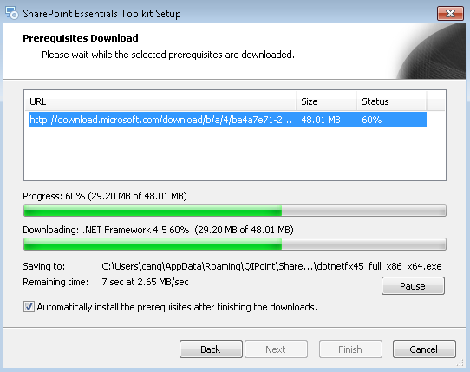

## Local Machine & Windows System Permissions Required

Please see the SharePoint Essentials Toolkit User Manual.

## Anti-Virus, Offline Sync Folders (i.e. Google Drive, OneDrive, Drop Box, etc.) and Performance

Please see the SharePoint Essentials Toolkit User Manual.

# SharePoint User Permissions Required

Users require specific Read permissions to be able to use the tool, see below for the specific permission levels required:

NOTE: The Visitor SharePoint Group and the READ Permission Level have these permissions already included by default.  
Also, providing the user with a Web Application User Policy of ‘Full Read’ will automatically grant the user all of these read permissions required to use this tool.

**View Items** - View items in lists and documents in document libraries.

**Open Items** - View the source of documents with server-side file handlers.

**View Versions** - View past versions of a list item or document.

**View Application Pages** - View forms, views, and application pages. Enumerate lists.

**Browse Directories** - Enumerate files and folders in a Web site using SharePoint Designer and Web DAV interfaces.

**View Pages** - View pages in a Web site.

**Use Remote Interfaces** - Use SOAP, Web DAV, the Client Object Model or SharePoint Designer interfaces to access the Web site.

**Open -** Allows users to open a Web site, list, or folder to access items inside that container.

**NOTE: T**he above permission levels are required for each site you will be running a report for. If the report is being run for a subsite, the account running the tool does not require permission on the root site to build a Broken Link report.

## Find/Replace Permissions Required

The user must have edit rights on the files/items being modified.

### Preserve Author

If you need to “Preserve Author and Date” information such as “Last Modified By”, “Last Modified Date”, the user running the job must have Full Control over the Site/List/List Item being updated to preserve this information.

## Office 365 Accounts

* When scanning Office 365 SharePoint sites, an Organizational account must be used, such as [user@mycompany.com](mailto:user@mycompany.com) or [user@mycompany.onmicrosoft.com](mailto:user@mycompany.onmicrosoft.com). Microsoft accounts (Windows Live IDs) such as [user@live.com](mailto:user@live.com) or [user@hotmail.com](mailto:user@hotmail.com), are not currently supported for authentication.

# Configuration

## Managed Paths

SharePoint uses managed paths to help organize you SharePoint Sites. By default, if you do not have any custom Managed Paths, you do not need to change anything, we have added the default Managed Paths for SharePoint already, such as “/sites/, “/personal/”.

### Getting the Managed Paths

If you are unsure of what the Managed Paths are for your environment, please contact your SharePoint Administrator.

#### Central Administration

You can obtain a list of all Managed Paths from Central Administration under “Application Management” -> “Manage Web Applications” and clicking the Managed Paths button in the ribbon:

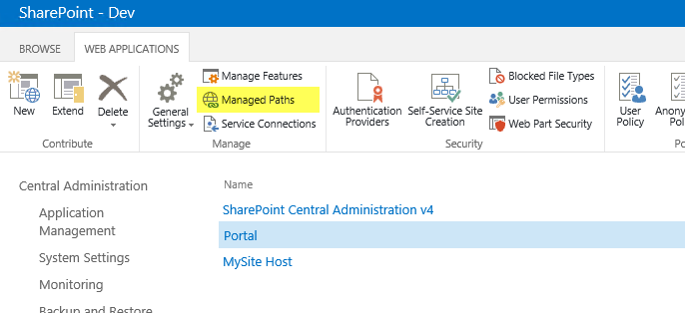

#### SharePoint Management Shell (PowerShell)

You can use the command below to retrieve a list of managed paths. Run this command on any SharePoint Server:

Get-SPManagedPath -WebApplication <http://webapplication>

### Errors if incorrect Managed Paths are specified

If you do not have the correct SharePoint Managed Paths listed here, if using the SharePoint Broken Link Manager tool, you may get paths with duplicate entries and false negatives in the reports. For example, if you have a Managed Path called ‘Projects’, the utility will not be able to understand the paths correctly when relative and will appear as <http://contoso/projects/projects/tasks>, and giving a false report of that URL being broken.

Currently only the SharePoint Broken Link Manager component relies on this setting to build reports correctly.

### Entering the Managed Paths

Open the SharePoint Essentials Toolkit “Settings” page (see below) to enter all Managed Paths in your SharePoint environment.

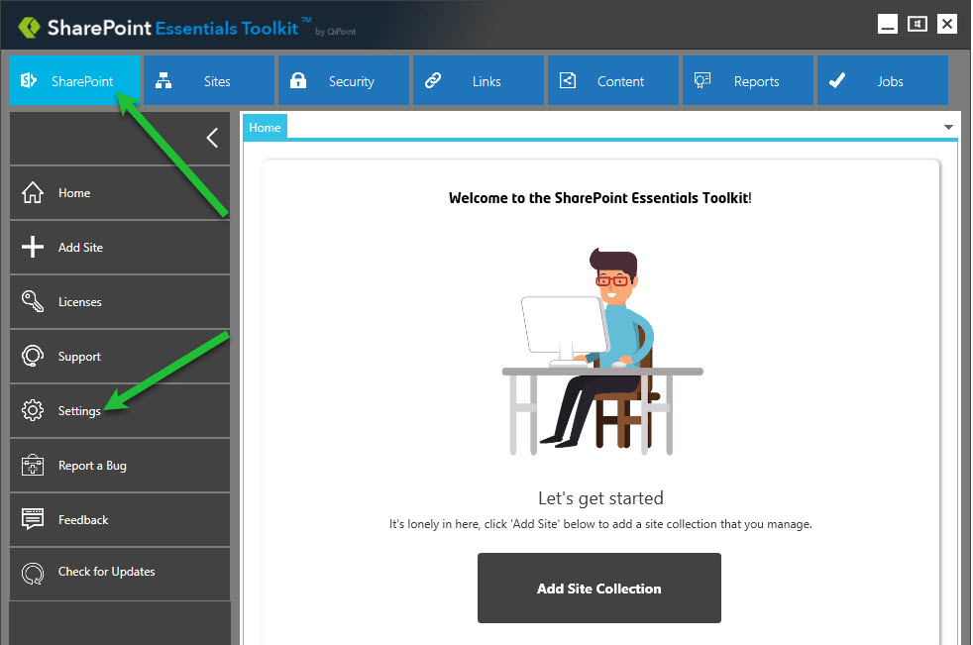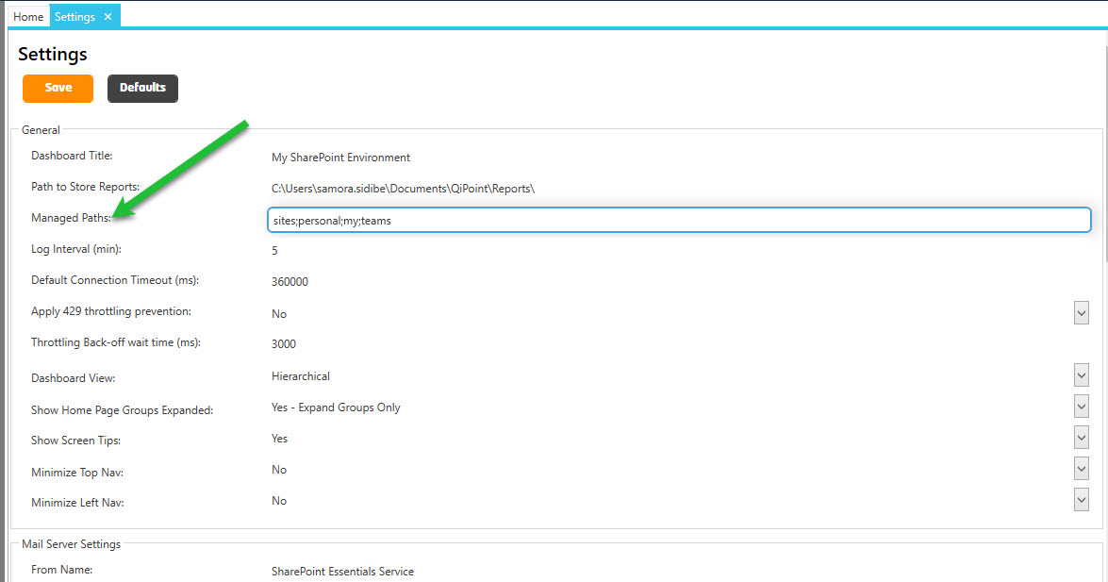

NOTE: The tool does not attempt to get your environment’s Managed Paths automatically because the tool could be run as an account with Read permissions, and therefore may not have access to Central Administration to get this information.

## Broken Link Manager Default Options

You can change the default options for the Broken Link Manager component by following the instructions below. These options will be set as the default values used in all reports that are run.

1. From the Top Navigation, click on the “Links” button
2. From the Left Navigation, click to expand “Manage”, then click the “Options” button

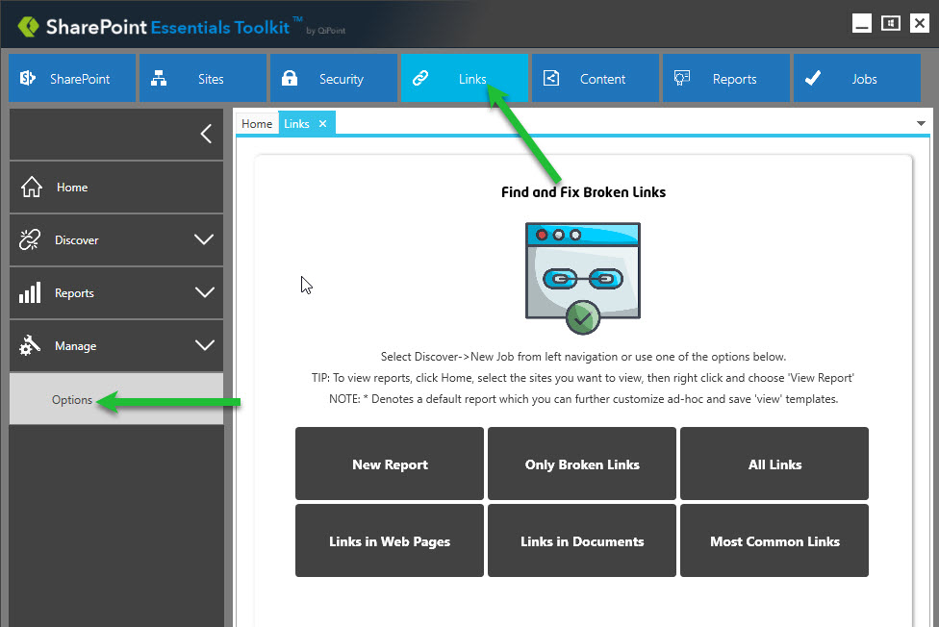

1. The following “Options” window will appear:

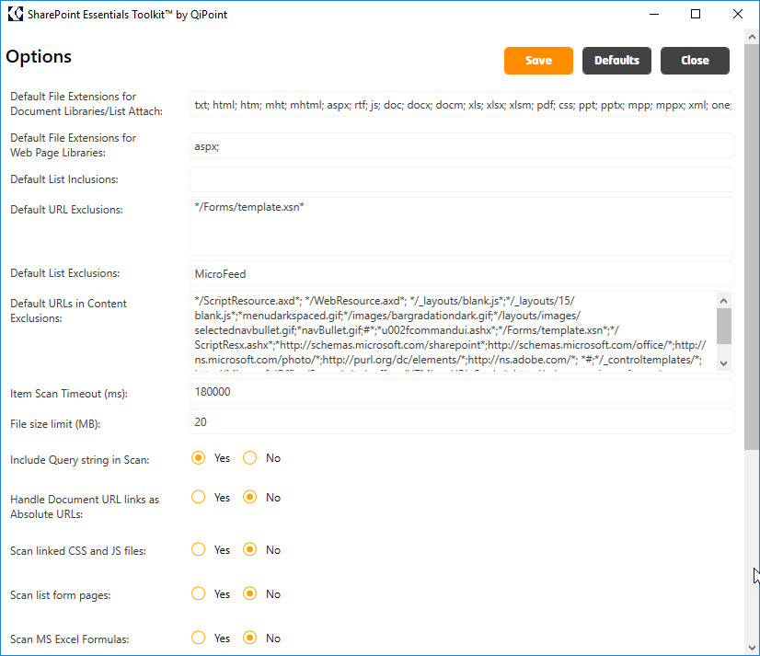

1. Complete the form and click “Save” to save changes or click “Close” if the settings are correct. The next section will provide descriptions of the fields.

Default File Extensions for Document Libraries/List Attachments

(Only used in Enterprise Version) These are the default file extensions for the files to include in scanning file contents. The file extensions can then be overwritten in the actual scan job settings prior to a scan. This will determine which files’ contents will be scanned when checking Document Library and List Attachment for broken links.

Default File Extensions for Web Page Libraries

(Only used in Enterprise Version) These are the default file extensions for the files to include in scanning lists based on the Page library template. The file extensions can then be overwritten in the actual scan job settings prior to a scan. This will determine which files’ contents will be scanned when checking Page Libraries (such as ‘Pages’ or ‘SitePages’ Libraries) for broken links.

Default URL Inclusions

(Only used in Enterprise Version) These are the default URLs to include when performing a scan. The URL inclusions can then be overwritten in the actual scan job settings prior to a scan. This applies to the URL of the SharePoint object such as the site, list or SharePoint Item/SPListItem.

* Separate multiple URLs using semi-colons ‘;’
* Only one match needs to be true for the rule to succeed
* URLs are case insensitive
* Wildcards (*) are supported, for example: ‘http://portal/sites/test1/*’ will only include URLs that start with ‘http://portal/sites/test1/’. ‘*/sites/*’ will only include URLs that have ‘/sites/’ in the URL
* Exclusion rules will be applied at this point
* Once a match is made, all the links within the item matched (such as a file or web page) will be scanned
* A log entry will show the item as being included or ‘matched’

Default List Inclusions

(Only used in Enterprise Version) These are the default Lists to include when performing a scan. Enter the List titles (use display name not internal name).

* Separate multiple list names using semi-colons ‘;’
* Only one match needs to be true for the rule to succeed
* The List inclusions can then be overwritten in the actual scan job settings prior to a scan
* List names are case insensitive.
* Wildcards (*) are supported, for example: ‘*Migrated*’ will only scan lists that have the word ‘Migrated’ in the title, all other lists will be skipped
* Once a match is made, all the items within the list will be scanned (pending other inclusion URL rules)
* Inclusion rules do not apply to links within the page/item/file contents that are matched
* Exclusion rules will be applied at this point
* A log entry will show the item as being included or ‘matched’

Default URL Exclusions

(Only used in Enterprise Version) These are the default URLs to exclude when performing a scan. The URL exclusions can then be overwritten in the actual scan job settings prior to a scan. This applies to the URL of the SharePoint object such as the Site, List or SharePoint Item/SPListItem URL.

* Separate multiple URLs using semi-colons ‘;’
* Only one match needs to be true for the rule to succeed
* URLs are case insensitive
* Wildcards (*) are supported, for example: ‘*/test/*’ will exclude all URLs that contain ‘/test/’ from being scanned. If the exclusion rule does not match the URL of the page/item/file, all links within the matched item will be scanned
* Exclusion rules do not apply to links within the pages/item contents
* Exclusion rules are applied after Inclusion rules
* A log entry will show the object as being skipped

Default List Exclusions

(Only used in Enterprise Version) These are the default Lists to exclude when performing a scan. Enter the List titles (use display name not internal name). The List exclusions can then be overwritten in the actual scan job settings prior to a scan.

* Separate multiple list names using semi-colons ‘;’
* Only one match needs to be true for the rule to succeed
* List name exclusions are case insensitive.
* Wildcards (*) are supported, for example: ‘*test*’ will exclude all lists that have the word ‘test’ in the title, all other lists will be included
* Exclusion rules are applied after Inclusion rules
* A log entry will show the list as being skipped

Default Link Exclusions

(Only used in Enterprise Version) These are the default URL links to exclude when performing a scan. This applies to the file contents only (URL links found within file contents) and not the actual SharePoint Item URL. Enter the URLs to exclude. The Link exclusions can then be overwritten in the actual scan job settings prior to a scan.

* Separate multiple link exclusions using semi-colons ‘;’
* Only one match needs to be true for the rule to succeed
* URLs are case insensitive
* Wildcards (*) are supported, for example: ‘*/scripts.aspx’ will exclude all URL links that have ‘/scripts.aspx’ in it, it will be excluded/skipped from the scan.
* Exclusion rules are applied after Inclusion rules
* A log entry will show the item as being skipped

Item Scan Timeout (ms)

This is the duration until the application will stop trying to process a SharePoint Item, Page or Document, such as when parsing an item and waiting to connect to URL addresses found within that item. Normally you should not have to change this value unless you see frequent timeouts in the logs.

File size limit (MB)

This is the maximum file size of an item to process when scanning links. Increasing this amount will impact the time it takes to parse large files. The timeout setting above still applies. By default, this is set to 20MB and can be increased or decreased as required.

Include Query String in Scan

Select yes to include the query string in scans (default). For example, a hyperlink with <http://someplace.com/default.aspx?productId=123> will be scanned including the query string (“?productId=123”). If ‘No’ is selected here, the URL that would be scanned will be <http://someplace.com/default.aspx> (which excludes the query string). Normally you would include the query string in scans unless they are causing issues when scanning. NOTE: Some web pages require a query string in its URL to return a valid page result. You may want to turn this off in specific link scans when including the query string produces undesired results.

By default, this option is on.

Scan linked CSS and JS files

(Only used in Enterprise Version) Select “Yes” to include linked CSS (Cascading Style Sheets) and JS (JavaScript) files that are associated with web pages.

For example, a web page with a tag:

<link rel="stylesheet" type="text/css" href="/_layouts/1033/styles/Themable/search.css?rev=T%2Bhraxktc1A8EnaG5gGMHQ%3D%3D"/>

When this page is scanned, the CSS file located at “/_layouts/1033/styles/Themable/search.css” will also be scanned for broken links (such as broken image links). The same concept for JavaScript files in <script /> tags.

This will likely significantly increase the time the job takes to complete as all linked document contents are parsed for these types of links and could result in the same CSS or JS files being scanned multiple times.

This option is useful if you need to see the impact a CSS broken image link or JS inserted link is causing across pages and sites.

By default, this option is off.

Scan list form pages

Turning this option on will perform a scan on list Form pages, such as AllItems.aspx and NewForm.aspx. Sometimes these pages may have been customized and have links that you want to scan within them.

By default, this option is off.

Scan MS Excel Formulas

(Only used in Enterprise Version) If this option is turned on, the tool will retrieve all MS Excel cells that have formulas with links and then report on those links, such as to another workbook in SharePoint to perform a calculation. This will increase the time to scan each MS Excel file.

By default, this option is off.

Debug Mode

Use this option only when troubleshooting invalid responses. If this option is set to Yes, the tool will attempt to include more details in the HTTP Responses in the Active Logs (and exported CSV logs). This will significantly use more system resources and is recommended not to turn this on unless troubleshooting. If this option is set to No, the tool will provide standard details in the Active Logs for HTTP Responses.

By default, this option is off.

# What will be scanned

This tool will scan the following for hyperlinks, as well as perform automatic Find/Replace:

## Outbound Links

* + Outbound Links to external sites.
  + Outbound links to (internal or external) SharePoint artifacts such as files, web pages, list items.
  + Outbound links to (internal or external) non-SharePoint content such as web site pages, files within your network, web applications.

## Supported Link Types

* + Http, Https
  + FTP
  + File shares and UNC paths
  + Tooltips that contain hyperlinks
  + Descriptions or Alt URLs within hyperlinks
  + Links to email addresses, such as ‘**mailto:**user@domain.com’. NOTE: Email addresses are always shown as valid (200 OK HTTP Status Code), it will not check validity of the email address or domain. There is an option in Settings to turn on/off detection of email addresses.

## SharePoint Web pages

* + Includes all links on a web page, including all content areas, web parts, and navigation areas (Top Navigation, Managed Metadata Navigation also supported, Quick Launch, Custom Navigation).
  + Page libraries and also Form (aspx) pages (Allitems.aspx, All Forms.aspx) within SharePoint Lists and Libraries are can be scanned for links.
  + HTML formatted links matching: (not case sensitive)

‘href’, ‘src’, ‘’source’, ‘background’, ‘title’, ‘_tooltip’, ‘alt’.

Examples include:

<a href=”http://www.somelink.com”>anchor display text</a>

<a href=”http://www.somelink.com” title=”http://www.somelink.com” ></a>

<image source=”http://www.somelink.com” alt=”http://www.somelink.com”></image>

<table background=” http://www.somelink.com” />

## Web Parts

### Supported Web Parts

The following web parts are supported by this tool:

* Script Editor Web Parts
* Xslt List View Web Parts
* Image Viewer Web Parts
* Page Viewer Web Parts
* Summary Links Web Parts
* Content Editor Web Parts

NOTE: Content Editor web parts with linked/embedded files (‘source text file’ to display Content Editor web part contents) are parsed separately if the file is in the SharePoint site (in a list or library). Content Editor web parts with links typed directly into the web part area (‘Edit Web Part’) are parsed for links.

IMPORTANT:  
(SharePoint Online only) Classic SharePoint Wiki Pages in SharePoint online that have Content Editor Web Parts (CEWP) will have links within these CEWP reported, however, Find \ Replace of links in Classic Wiki pages in SharePoint Online are no longer supported from Oct 12th 2020 forward. This is due to a change in a Microsoft SOAP web service.

The above web parts (with exception of Find & Replace of links in SharePoint Online Wiki pages with CEWPs) are fully supported by the tool and links found within them can be corrected using the Find / Replace option.

### Modern Web Parts

The following Modern Web Parts are supported:

* Text Web Parts
* Quick Links Web Parts
* Link Web Parts

### Custom Web Parts

There is limited support for custom web parts. Depending on how the Web Part is written, some properties and contents of a custom web part can be supported by the tool. Typically, web parts that inherit from SharePoint Web Parts such as a custom Content Editor Web Part, will still work with our tool and can be checked for links. Please contact us for more information on this.

### Web Part Properties

The out-of-the-box web part properties are supported by this tool. Links inside of the web part properties such as Title URL and Help URL are validated by the tool and can also be replaced by the tool Find / Replace option.

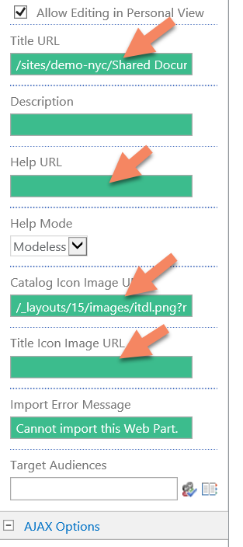

### JS Links / Display Template URLs

The tool will check web part JS Link sections for URLs. They will also be replaced if Find & Replace is used.

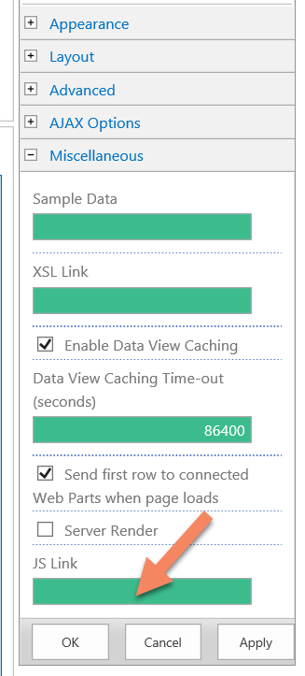

## Navigation Links

The tool will check the Top Navigation / Global Navigation and Quick Launch / Current Navigation for links. They will also be replaced if Find & Replace is used. Navigation that is based on Managed Metadata (term set), or that is using Structural Navigation for the navigational links, are both fully supported.

NOTE: Navigation Links will appear with Link Type = QuickLaunch or LinkType=TopNavigation, Item Title = ‘Site Navigation’. You will also see navigations in a duplicate row for ‘LinkType=WebPageContents’ for each web page. This is by design.

## Document ID Links

The tool will automatically resolve Document ID links using the SharePoint Document ID web service of that Site. The Document ID Service will either REDIRECT a user to the file if a match is found, however, if the link is ‘broken’, the Document ID service shows a message such as “No documents with the ID HCH2YEEPCJYU-5-45 were found in this site collection.” The tool will recognize this and correctly show a 404 ‘Not Found’ in the Broken Link Report. Please ensure you are using the latest version of our tool as this was a new feature as of SET version 4.4.3.0.

## SharePoint Lists & libraries

* + Includes all SharePoint List Definition Types except Invalid Lists and External List types.
  + Includes all column meta-data that may contain links (such as Text, Multi-line Text, Hyper-Link data types).

## OneDrive

* + Content located within Lists or Libraries in User OneDrives are supported.
  + The account running the tool must have access to the content.  
    NOTE: You can use Permissions Manager to add an account to users’ OneDrive as a Site Collection Administrator and later remove that access with the tool.

## InfoPath Forms

* + InfoPath Form fields with URLs will be scanned for links and can be replaced.
  + InfoPath Form Template data connection reference links are supported, they can also be replaced using our tool.
  + The InfoPath URLs and Data Connection Links require removal of the following highlighted entries:

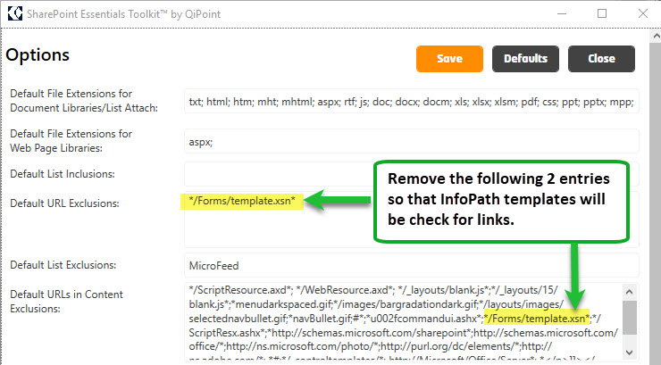

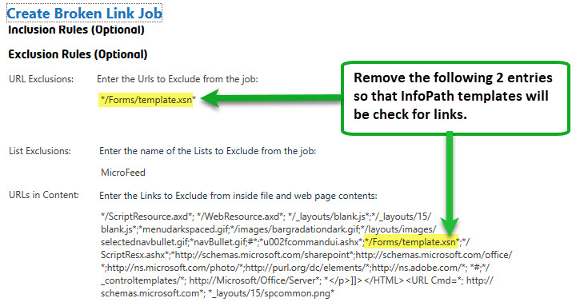

## Inside File Contents

This tool will optionally parse inside of file contents such as inside of PDF, MS Word, MS Excel etc..

Broken Link Manager supports:

* Document Library file contents and List Item Attachment file contents
* Parsing Text friendly file formats (ASCII) such as xml, xslt, mht, rtf, txt, js, css, html, aspx, php, etc. (Tip: If it is text readable in Notepad, it typically can be scanned).
* NOTE: CSS Files – when scanning partial/relative paths within CSS files, please note that they are relative to the CSS file directory, not the document. For more information on this, see https://www.w3.org/TR/CSS1/
* Parses links inside of PDF documents (except for PDF files that have been scanned as images).
* Microsoft Office ‘95 versions and higher.
  + Parse inside of Microsoft Office Word, Excel, PowerPoint, and Project documents.
  + Microsoft Word for Macintosh 98 to X, including other .doc applications such as OpenOffice and AbiWord.
  + MS OneNote notebooks
  + Supports MS Office documents that have images that have hyperlinks behind them.
  + Supports MS Office documents with links embedded in tables
  + MS Visio (.vdx, .vsd, .vsdx) are supported by the tool.
  + MS Excel Formulas are supported by the tool. There is an option to enable this feature under Links->Manage->Options. If enabled, the formula where the URL is found, will display the Cell Value in the Link Description field of the report to help you find the Cell in question (that has the link). The Field Type will be identified as “DocumentFileContentsExcelFormula” so that you can sort, filter or group by this column. The worksheet is also provided in the report to help find formulas with invalid links.
  + MS Office Macro enabled Documents with Visual Basic Code that contain Links: Macro enabled Office documents such as .xlsm or .docm that have macros with links are supported by the tool. The Macro/Module name will show in the report as well under the Field column.
  + MS Office files that have Embedded Objects (OLE) that are hyperlinks are scanned. However, the embedded objects themselves are not scanned for links.
* MS InfoPath Forms and URLs within the template.xsn files are supported. You may need to remove the default template.xsn exclusions rule to include these in the job. See above “InfoPath Forms” for more details.

## Workflow Task Items

* ‘Link to Document’ and ‘Send To’ aspx stub links are supported.
* Workflow Task list item ‘Email Body’ fields are supported for link detection and correction.

## Send to Location with ‘Leave a link’ and ‘Link to Document’ Content Types

If the SharePoint environment is configured to use a Send To Location with ‘Leave a link’. When a document is sent to another location, this option will leave a aspx file as a link to the document’s new location. The tool supports reporting on the links in these aspx ‘stub’ pages, the tool is also able to fix these links using the Find / Replace option.

Items based on the Content Type ‘Link to Document’ links are supported.

## Linked CSS & JavaScript files

* + Optionally, you may scan linked CSS and JavaScript files for broken links (which are referenced within a web page). You can turn this feature ON/OFF by going to Scan Links (tab) -> Manage -> Options -> "Scan linked CSS and JS files".
  + If this feature is turned ON, when scanning pages for broken links, its contents will also be scanned for potential broken links, such as broken image links if a page has a CSS (Cascading Style Sheet) or JavaScript file referenced (such as in a <script /> <link /> reference tag).
  + These types of links can be identified by viewing the column “Field” in the report. Linked content that is scanned will be in the format “File Contents: companyStyle.css”.
  + You can also filter or group these in your report by right clicking on the column “Field” and selecting “Filter Editor”, then add a filter to only include/exclude ‘linked’ file contents, this can help when resolving broken links within CSS & JavaScript files and reviewing the impact they may have on your web pages. You can also group by the Field column to view all links for a ‘linked css’ file. See below:

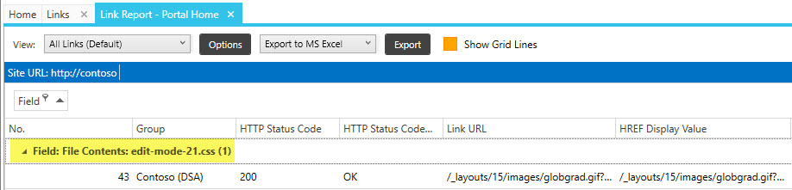

# What will NOT be scanned

This tool will not scan:

## Links

* + Links that end with ‘**#**’ are skipped (can be included by removing exclusion rule).
  + Links within ‘**javascript**:’ in HTML tags are skipped, however the JavaScript source file links are checked.
  + SharePoint OOTB Links such as ‘appredirect.aspx’ ‘_layouts/userdisp.aspx’ ‘_vti_bin/spsdisco.aspx’ are part of the Default Exclusion rules and are skipped by default. To include these, remove them from the Default Exclusion Rules in Links->Manage->Options.
  + Any links that you add to the “URL Exclusions” list will be skipped.
  + MS Word bookmarks are not treated as URL links and are skipped.
  + Data Connection links within MS Office documents are not supported.
  + Links listed in the “Link URL Exclusions” settings are skipped (see Links (tab) -> Manage -> Options -> “Default Link Exclusions” to set up the default URL exclusions.
  + Inbound links coming from external websites are not scanned. The tool will have no way of knowing what sites on the internet or other networks or servers have links to your site. Only Outbound links will be scanned that are found in your SharePoint environment, this includes all links to external sites or links internal to your environment.

## Lists & libraries

* + Does NOT include invalid list types.
  + External Lists are not supported.
  + Calendar Overlays links are not supported.
  + ‘Copy Source’ fields in SharePoint are sealed/Read-only and will appear in the reports and validated but cannot be changed/replaced by the tool.

## File Contents

NOTE: Below items relate to scanning inside of file contents, metadata scanning is supported for these types however the tool does not support parsing links inside of the file types:

* + We cannot list all possible file types out there, but the following popular file types (that we know of) are not currently supported by our tool for link detection or find/replace:
    - Adobe Illustrator (.ai) – not supported
    - Adobe PhotoShop (.psd) – not supported
    - AutoCAD (.dwg, .dxf) – not supported
    - Corel WordPerfect (.wpd) – not supported
    - AutoDesk (.3ds, .prj) – not supported
    - MS Outlook Email (.msg) – not supported
  + MS Word/Excel/PowerPoint/Project text-based links are not supported. (Text based links: do not have a hyperlink but just text, such as (1) <http://contoso> vs (2) http://contoso, (2) a text based URL is not ‘clickable’). Actual hyperlinks are supported. Text-based links in MS Excel are supported if you turn on the option to include Excel Formulas in Job.

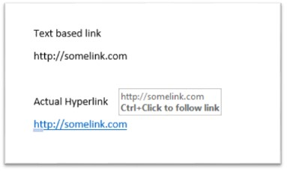

* + MS Office OLE / Embedded Objects contents are not supported.
  + Images: Links that are displayed in the actual image are not supported.
  + Videos: Links that are displayed within a video file are not supported.
  + PDF: Links inside of PDF files in the repeatable ‘footer’ of a PDF are not supported
  + MS Excel: URLs added when user clicks Data->Get Data, see below

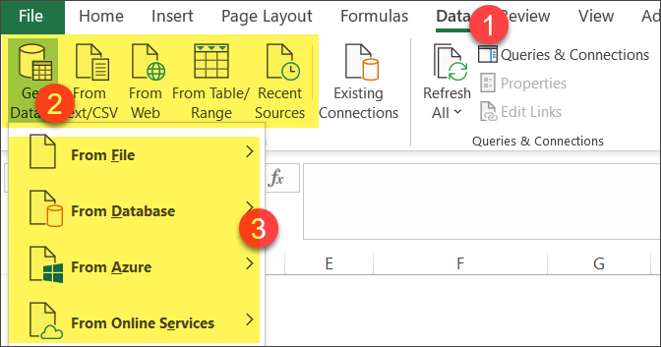  
The tool will not report on MS Excel data linked this way, nor can it fix these types of links (embedded data).

* + MS Excel: Links that are inside of Visual Basic Code in MS Excel are not supported.

## Compressed Files

Links within files that are in compressed file types such as .ZIP and .RAR will not be extracted for URL/link parsing. Metadata for any .ZIP or .RAR files will be parsed for links, however, contents within these files will not be parsed for links.

## InfoPath XSN Files

InfoPath forms, metadata and content are supported, however the .xsn file itself (InfoPath Form Template) cannot be parsed for links with the tool.

## Web Parts

(SharePoint Online only) Classic SharePoint Wiki Pages in SharePoint online that have Content Editor Web Parts (CEWP) will have links within these CEWP reported, however, Find \ Replace of links in Classic Wiki pages in SharePoint Online are no longer supported from Oct 12th 2020 forward. This is due to a change in a Microsoft SOAP web service.

## OneDrive / My Sites / Personal Sites

Links to OneDrive, My Sites and Personal sites are supported.

NOTE: User Profile metadata properties are not supported. SharePoint Lists & Document Libraries within OneDrive and My Sites are fully supported.

# Performing a Scan for Broken Links

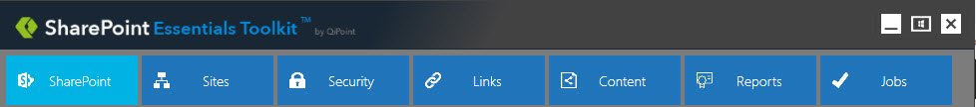

## Getting Started

There are 3 ways you can perform a scan for broken links.

1. From the Home Page Dashboard, right click on a site (that you want to build a report for) and click “Create Reports” -> “Broken Links”.

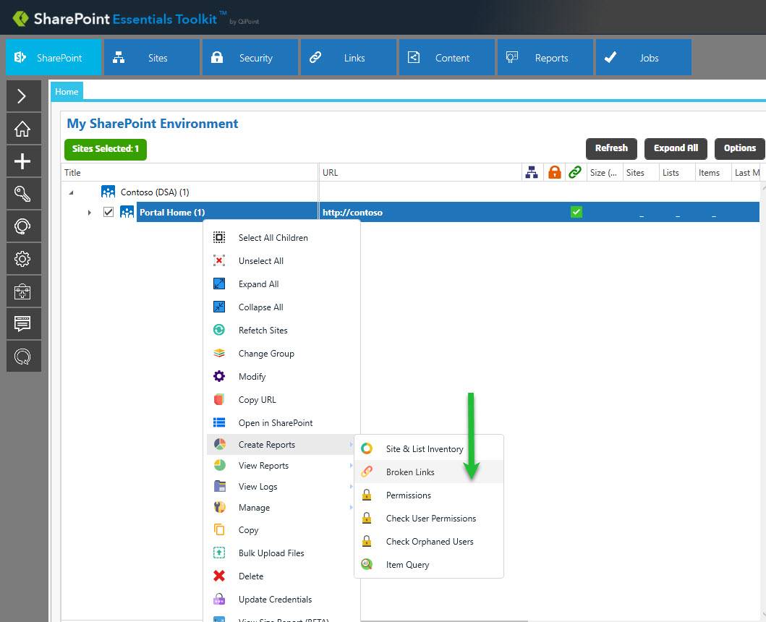

1. Click on the “Links” button in the Top Navigation, click on the “New Report” button in the middle-center of the “Links” window.

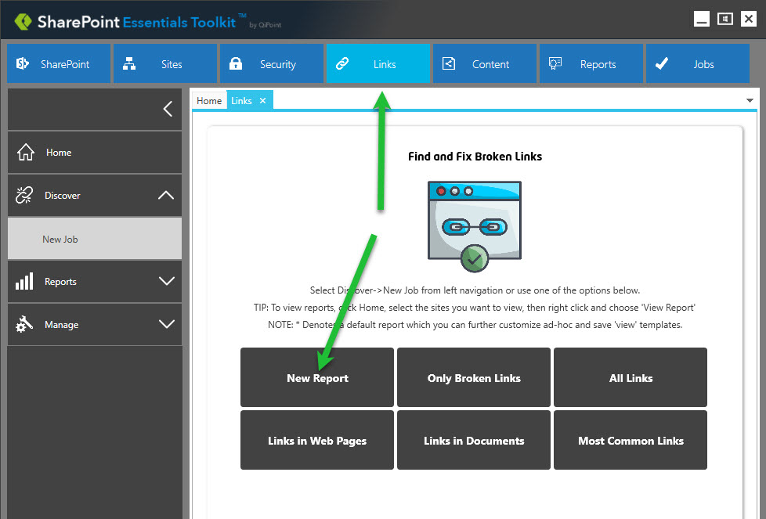

1. Click on the “Links” button in the Top Navigation, click on the “Discover” button in the Left Navigation to expand it, then click “New Job”.

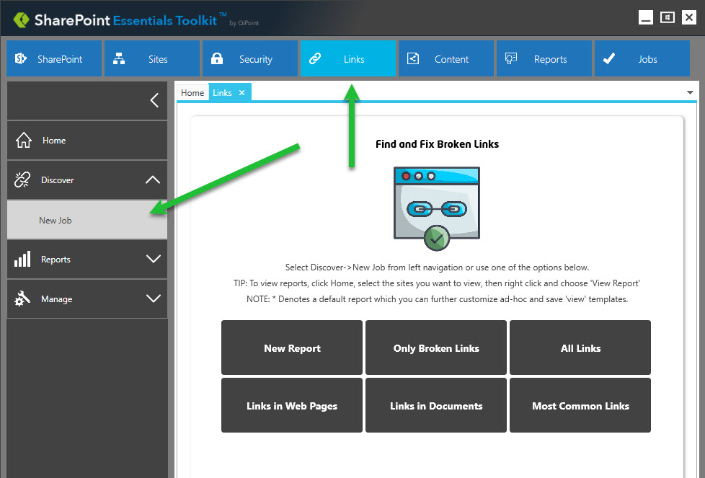

## Start a Job

1. Open “SharePoint Essentials ToolkitTM”
2. Use one of the options above to open the Broken Link Manager “New Job” window
3. A “New Job” window will appear called “SharePoint Broken Link Manager” (below screenshot)

(NOTE: This page below may appear different depending on the version you are using)

1. Complete the form. Fields with an asterisk * indicate required fields

See “Scan Options” (next section) for a description of each option

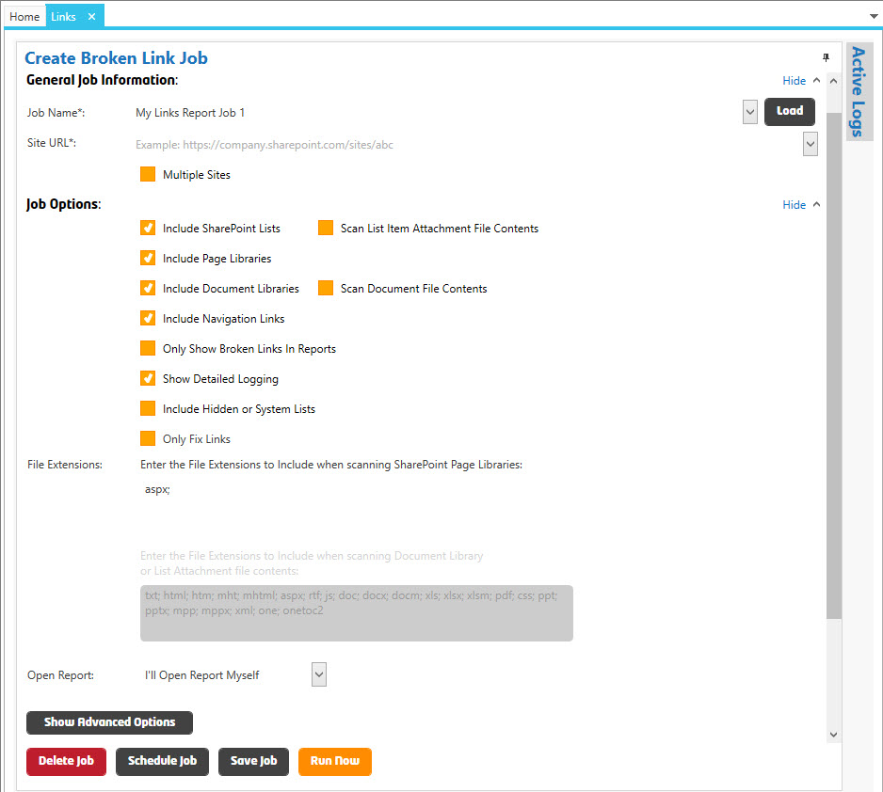

1. Click “Run Now” button to start the job immediately

## Scanning Multiple Sites at Once

To create jobs for multiple sites and subsites, see the “SharePoint Essentials Toolkit User Guide” under the section “Batch Processing Jobs for Multiple Sites”.

## Job Options

### Job Name

This is the Name of the job. A folder will be created in the report directory for every job. You can use the same Job Name to group reports. The job name will be used as the report name and will be used to help identify the report if scheduled. You must rename the job if you want to save the job for future re-use.

### Site URL to Scan

This is the absolute URL of the site you want to scan for broken links. This can be the path to a Site Collection top level (root) site, or a sub site.

**Example:** <https://companyportal/sites/hr> or <https://companyportal/sites/hr/projects/capital_site/>

Do not include the page path in the URL

Multiple Sites  
Select this option to run a ‘multi-threaded job’. If this option is selected, you will NOT be able to run a manual job using ‘Run Now’, you need to schedule the job as it will be broken down into one job per site. These jobs will run in parallel and can be viewed from the Scheduled Jobs section. Once complete, job reports can be accessed from the Scheduled Jobs page, the Job History page and also from the Home Page Dashboard by right clicking on one or more of the sites.

### Credentials

Select the authentication type and enter the credentials used to access this site.

#### **Default SharePoint Authentication**

Automatically determines Authentication to connect to the SharePoint site. This will work in most cases when SharePoint is hosted on your internal company network. Enter the custom credentials to use for this site. If your environment is using a custom login screen, such as one that requires Multi-Factor Authentication/a PIN, is using ADFS, or has SSO enabled, use Web Based Authentication below.

#### **Office 365**

Use this option to connect to Office 365 hosted SharePoint sites. This applies to both Office 365 non-federated environments. If using a Federated/ADFS enabled Office 365 environment or if your Office 365 environment is using a custom login screen, such as one that requires a PIN, use Web Based Authentication below.

#### Web Browser Authentication

Use this option to force the tool to prompt you with a pop up window that will display your company login page to provide credentials. If you are using Office 365 with an ADFS server with custom login page, Multi-Factor Authentication/a PIN, is using ADFS, or has SSO enabled, use this authentication type. If you want to schedule jobs, click to “Remember Credentials” and run the job once, it will remember these credentials for the scheduled job.

#### Remember Credentials

Select this option to store the username and password. Passwords are stored using strong ‘salted’ encryption.

### Job Options

#### **Include SharePoint Lists**

Check this option to scan all links within Lists (such as Tasks, Issues, custom lists).

#### **Scan List Item Attachment File Contents**

Scans all links within List Item attachments.

#### **Include Page Libraries**

Scans all links within lists based on the Page Library template.

#### **Include Document Libraries**

Scans all links within Document Libraries.

#### **Scan Document File Contents**

Scans content within each file with a matching extension specified in “File Content Scan”.

#### **Include System Lists**

Scans all links within Hidden System lists and libraries.

#### **Only Show Broken Links in Reports**

Check this option to only show broken links, links that are ‘OK’ will not be shown in the report but will be shown in the log file.

#### **Show Detailed Logging**

Check this option to show details of every URL scanned in the Active Logs. This will affect the performance. We recommend after your jobs are working fine, to disable this option unless needed for troubleshooting.

#### **Skip Validation of Links**

Check this option to force the tool to ignore validation of links (checking if they are broken or not). This will significantly improve performance (30-60% faster). This can be useful if you only need an inventory of all links and locating specific links but do not require the HTTP Status Code, to determine if they are broken or not.

This option is useful in Find Replace jobs where you need to fix links and already have done link validation.

#### **Open Report Once Complete**

Check this option to automatically open the report once the job is complete. This option is hidden/not available for ‘Multiple Sites’ jobs.

### File Extensions

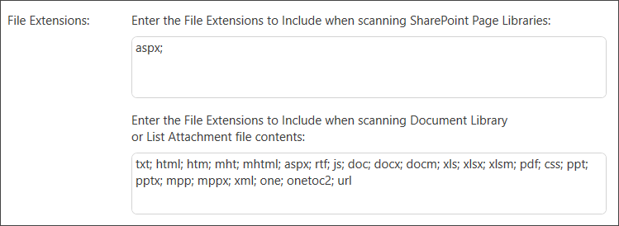

If the option to scan file contents is enabled (for List Attachments or for Document Library files), you can specify the extensions to include in the scan here. If you selected “Include Page Libraries”, the file extensions textbox will become enabled.

Only files whose extensions match those listed here will have contents scanned for broken links.

The first textbox in this section is for scanning within Web Page Libraries (enter the file extensions to include in these libraries when performing a scan), by default usually most environments only have aspx pages in the Web Page Libraries (such as “Pages” or “Site Pages”).

The second textbox in this section is for scanning within Document Libraries (enter the file extensions to include in these libraries when performing a scan).

### Inclusions Rules (Optional)

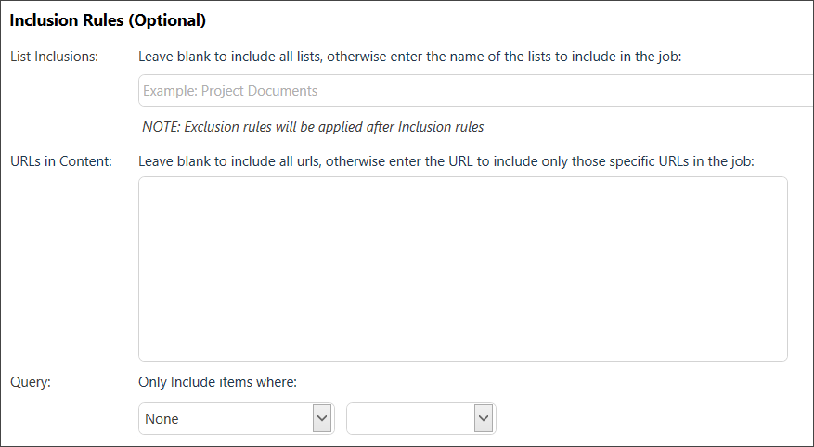

#### **List Inclusions**

Use this section to filter and only scan specific SharePoint Lists in the job. Use List Title (display name), not the List URL here. The user can specify what Lists to include in the scan by entering the names lists in this section, once you enter a SharePoint List in this section, all other lists not entered here will automatically be excluded.

If the name of the list exists in multiple sites, they will all be included if the List title (display name) matches. Wildcards (*) are supported, so if you want to include all lists and libraries that have the word ‘documents’ in the List Title, you can enter “*documents*” and all lists and libraries with ‘documents’ will be included in the scan. These values are not case-sensitive. Once a match is found, all links within the list and its items will be scanned (inclusion rules do not apply to page/item/file contents). Separate Lists using semi-colons ‘;’.

#### **URLs in Content**

If any URLs/paths are entered here, the tool will only report on/replace URLs inside content (inside web pages, within documents, or metadata) that match those specified here.   
Specify the drive letter or URL that you ONLY want to include in the job. Use this if you are looking for URLs matching a certain pattern using a * as wildcard.  
Example: P:\fileshare\*;M:\* will only report on (and only fix, if Find/Replace rules are set), links that start with P:\fileshare\ or anything starting with M:\ in URL path.   
Entering [https://portal/sites/hr/*;http://extranet/*](https://portal/sites/hr/*;http:/extranet/*) will only report on (and only fix, if Find/Replace rules are set), links that start with https://portal/sites/hr/ or http://extranet/.

#### **Query**

**You can specify to only include items that match criteria matching criteria specified here. The tool will filter the results from SharePoint before processing.**

**You can choose to only do a “Differential Scan” by selecting the options below. It will then only build a report against items and files that have been modified since the last Broken Link Manager Report date.**

**Choose “Last Report” for a “Differential Scan” (to only check links since the last report date) or you can specify a custom date here:**

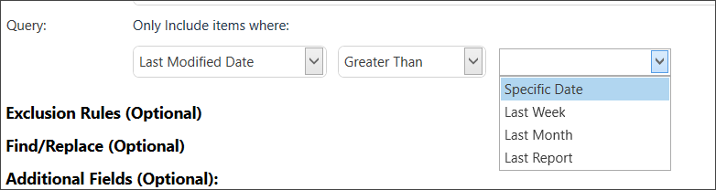

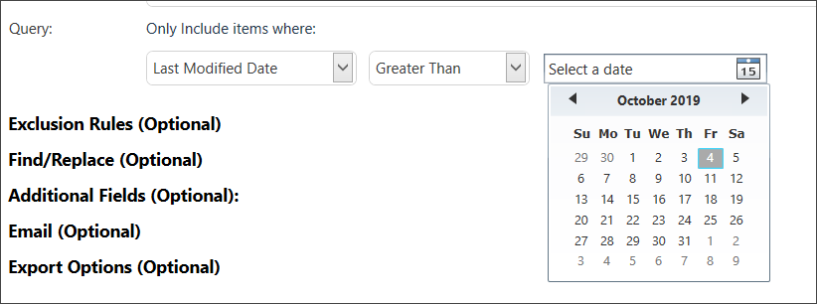

**You can also use the ‘Query’ option to only scan links for folders or items that match criteria given here.**

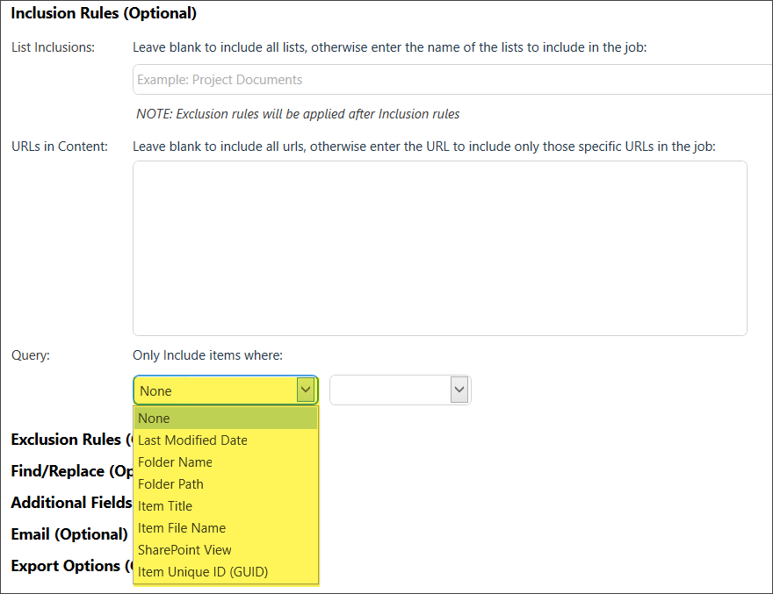

**Last Modified Date:** Filters the list items by the date selected before the job is run against any items. This can help improve performance but will exclude any items that do not match this date criteria.  
**Folder Name:** You can specify a folder name to include in the job. You can only enter a single folder name here. Use 'SharePoint View' if you need to specify multiple folders.  
**Folder Path:** You can specify a folder path to include in the job. You can only enter a single folder path here. Use 'SharePoint View' if you need to specify multiple folders.  
**Item Title:** You can specify an Item name to include in the job. You can only enter a single entry here. You can use 'Contains' to match multiple items.  
**Item File Name:** You can specify a File name to include in the job. You can only enter a single entry here. You can use 'Contains' to match multiple fails.

**TIP: You can enter "Contains" .xls in the "Inclusion Rules→Query" to only parse Excel files. The tool will match any item file name that contains an extension matching .xls.**

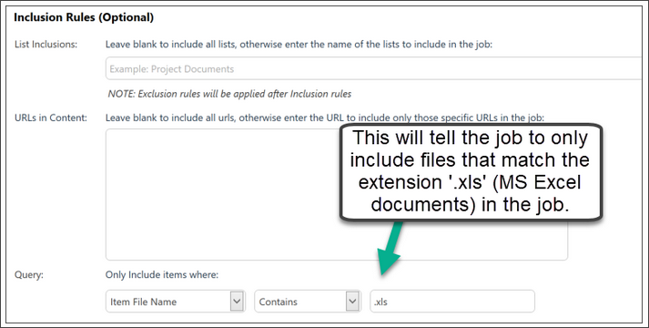

### Exclusion Rules (Optional)

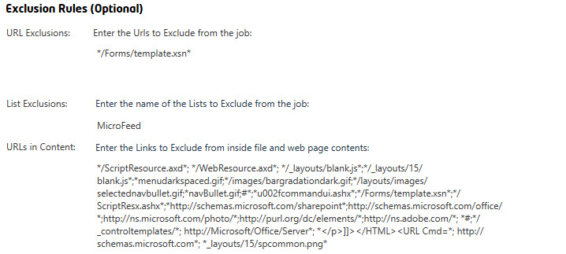

#### **URL Exclusions**

Enter the URLs of the SharePoint target sites, lists, libraries, items that you want to exclude in the job. You can enter an exact URL to match or partial using wildcards (*). For example: entering [https://sharepoint/sites/hr/ap/*](https://sharepoint/sites/hr/ap/*) here will exclude the HR Accounts Payable site (“/ap”) and all contents within it from the scan. Separate URLs using semi-colons ‘;’.

#### **List Exclusions**

The user can enter the names of lists to exclude in the scan here. If the name of the list exists in multiple sites, they will all be skipped if the List title (display name) matches. Wildcards (*) are supported, so if you want to include all lists and libraries that have the word ‘documents’ in the List Title, you can enter “*documents*” and all lists and libraries with ‘documents’ will be included in the scan. These values are not case-sensitive. Once a match is found, all links within the item will be skipped. Separate Lists using semi-colons ‘;’.

#### **URLs in Content**

The user can enter URLs to exclude in the job. This will be applied against the links found within items, documents, files and page contents (it is not applied against the SharePoint site/list/item URLs, use ‘URL Exclusions’ or ‘List Exclusions’ options above for excluding SharePoint content from scans.). Wildcards are supported. These values are not case-sensitive. Separate URLs in Content using semi-colons ‘;’.

##### Excluding URLs in Custom Navigation or Custom Footers

You can specify an **ID** or **CLASS** DIV attribute to exclude. Setting a value in “URLs in Content” that has format:

$$ID=your HTML div control ID$$

or

$$CLASS=your HTML div control class$$

**RECOMMENDED**

Use a DIV ID to filter (instead of CLASS, as a class could be listed in pages multiple times and produce possibly unexpected results). Will cause the tool to skip ALL LINKs found within this tag.

**Example:**

We have a DIV with class “nav-container”, below

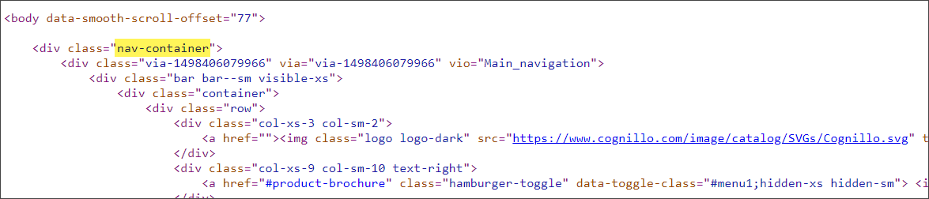

To exclude all links inside this tag, such as the <https://www.cognillo.com/image/catalog/SVGs/Cognillo.svg>

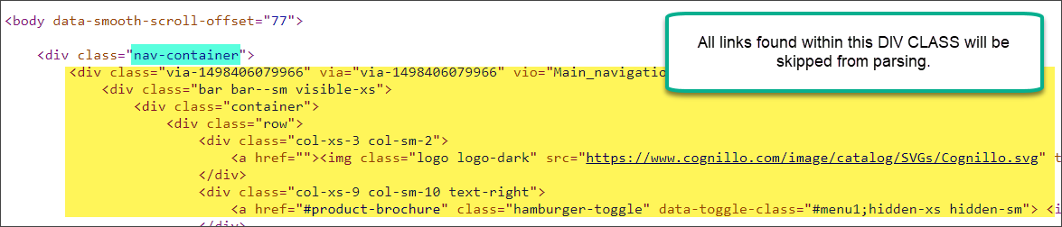

We would enter

$$CLASS=nav-container$$ in the URLs in Content EXCLUSION Rules.

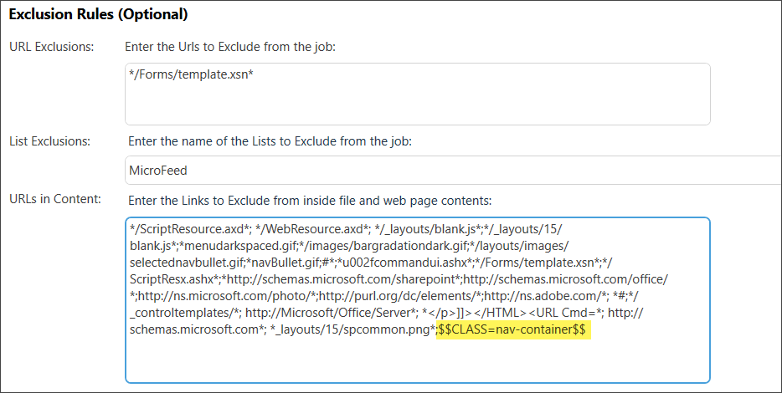

Below is an example if we used a DIV “ID” (recommended) instead of CLASS.

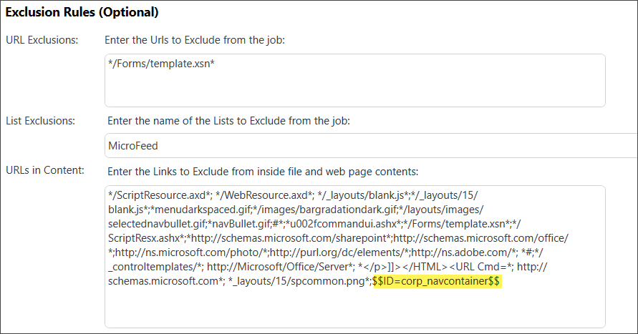

#### NOTES on Inclusion/Exclusion Rules:

* **Exclusion rules will be applied AFTER Inclusion rules (if any).**
* **If the “Minimal Download Strategy” feature is enabled on a site, the URL changes to a path similar to** <http://contoso/_layouts/15/start.aspx#/Shared%20Documents>**. Do not use the path in the address bar if using “Minimal Download Strategy” AND URL Inclusions/Exclusions as this path is virtual and will not be used by the tool. For example, for lists, use the list URL specified in the SharePoint List Settings page when using URL Inclusions/Exclusions for lists, such as** <http://contoso/Shared%20Documents>**.**

### Find/Replace (Optional)

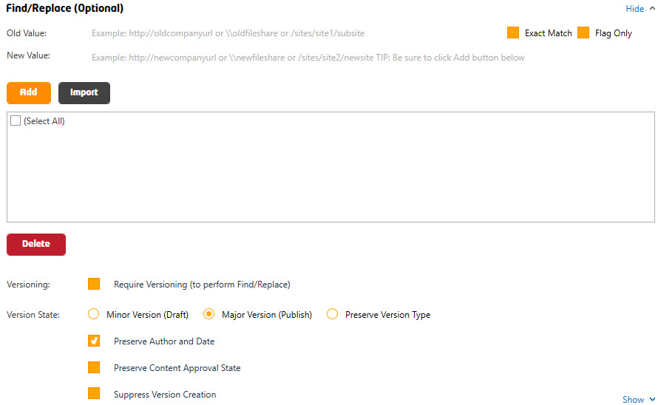

You may use the Find/Replace feature to automatically fix target URLs.

Find/Replace will modify URLs (regardless of HTTP Status Code) that match a specific user-defined value. Find /Replace will search within all content where it performs a scan for broken links, such as SharePoint Page contents, MS Office documents, list item metadata, PDF file contents, text files, html files, etc. The tool will only attempt to perform a Find / Replace on links within the most recent version of an item. It will not attempt to replace/fix any links in version history.

See the below section “Automatically Finding and Replacing Links” for more information.

#### Old Value and New Value

##### **Old Value**

Enter the old URL value you are searching for and would like to replace (not case sensitive).

This can be a complete absolute URL or partial. For example: <http://oldserver> will match <http://olderserver> and <http://oldserver/sites/test1>. A ‘New Value’ of <http://newserver> would replace <http://olderserver> with <http://newserver>, and <http://oldserver/sites/test1> with <http://newserver/sites/test1>. You can also replace partial strings/text within the URL, for example, an ‘Old Value’ of ‘/oldpath/site1/site2/’ and ‘New Value’ of ‘/newpath/site1/’ would replace ‘http://www.company.com/oldpath/site1/site2/lists/docs/’ with ‘http://www.company.com/newpath/site1/lists/docs/’

##### **New Value**

Enter the new URL value you want to use to replace the old value with (not case sensitive).

##### Exact Match

Checking this on will force the replace to only occur when an exact match is found (forces Old Value to ‘matching’ be case sensitive). The complete URL string entered in Old Value must match exactly the URL found before it does a link replacement.

##### Flag Only

This will not cause any changes and will only flag items as matches for a find/replace. This is useful to test the scan before performing a find/replace.

This will not cause any changes and will only flag items as matches for a find/replace. This is useful to test the scan before performing a Find/Replace.

There are 2 places in the report that identify a link that is found and is to be replaced once executed:

1. The flagged items will appear in the Broken Links report under HTTP Status Code with an asterisk * appended, such as 200*.
2. The flagged items will appear in the Broken Links report under New Link URL and New HREF Display Value fields as: (it will display the new URL value that will be used once executed).

*\*\*Match found - Flag Only:*[*http://newserver/somepath*](http://newserver/somepath)

**IMPORTANT**: Exact Match only works with absolute URLs, not relative links.

**IMPORTANT**: When adding Find/Replace URLs, **you do not need to select/check any of the items**. The checkbox below is only used if you are selecting a replacement rule to delete.

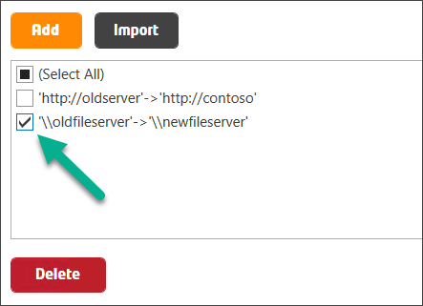

##### Add

Click this button once you have added an ‘Old Value’ to replace and a ‘New Value’ or selected the ‘Flag Only’ option.

##### Import

Click this button to bulk import Find/Replace values from a MS Excel file. First column should be ‘Old Value’, second column should be ‘New Value’. Column header is not required and should not be used.

**TIP:** Remove all hyperlinks (in MS Excel) prior to the import to ensure the URLs are imported correctly.

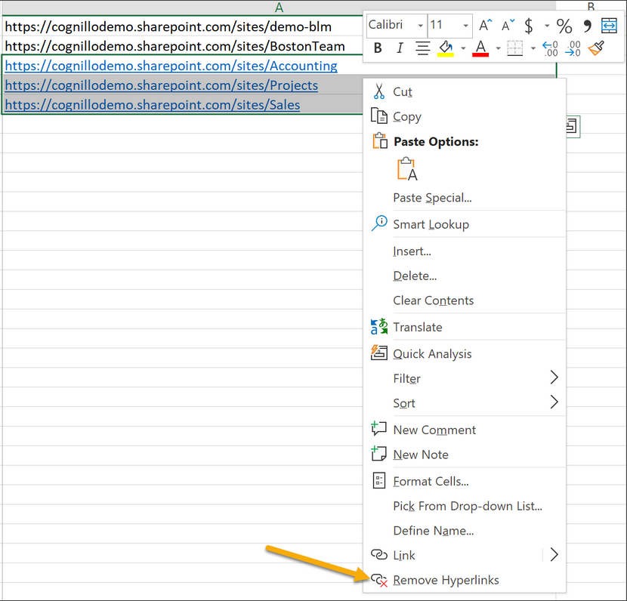

#### Versioning: Require Versioning (to perform find/replace)

This is a safety feature to first check if Versioning is enabled on SharePoint List where an item/page/file has a Find / Replace match. If turned on, the tool will not fix any links if List Versioning is off for the Item (where a Find / Replace match is found).

This is an optional safety mechanism to help ensure items/pages/files have a ‘version’ backup copy if a Find / Replace is performed.

This option uses the following logic:

**YES (this option is enabled)**

If a Find / Replace match is found. The tool will check if versioning is enabled on the item’s list, if List Versioning is enabled, a ‘Find / Replace’ will be performed and a new version by default will be created with comments in the ‘Check in Comment field’. See example below:

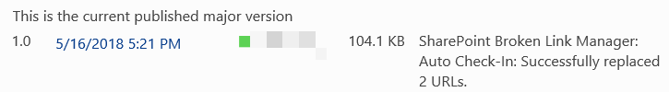

If List Versioning is NOT enabled on the list, but a Find / Replace match was found, since this setting is ON, the tool will NOT perform a Find / Replace and it will show a warning message in the Active Logs that this Find / Replace was skipped since list versioning is not enabled.

**NO (this option is disabled)**

If a Find / Replace match is found. The tool will try to do the Find / Replacement of the link, regardless if the List Versioning is enabled or not.

#### Version State

(Only used if Versioning is enabled on SharePoint List where an item/page/file has a Find / Replace match). This option only applies to Find and Replace where the file to be updated (with a Find and Replace), is in a SharePoint List that has Versioning enabled. Once a Find/Replace match is found, the utility will automatically check out and check in the file and create a new version for it (if versioning is enabled on the list). The tool never modifies the List Versioning settings in SharePoint.

This Version State option specifies the type of version that will be created if a Find and Replace occurs.

**Minor Version (Draft)** – If a Find and Replace match is found, the tool will perform the Find and Replace and it will save the updated item as a Minor version.

**Major Version (Publish)** – If a Find and Replace match is found, the tool will perform the Find and Replace and it will save the updated item as a Major version.

**Preserve Version Type** – If a Find and Replace match is found, the tool will check the current version of the item (check the version number and determine if it is a major or minor version, such as 2.3 which would be minor, or 3.0 if it was a major version), perform the Find and Replace and it will save the updated item as the same version type as it was originally. This way, if the item was in Draft state and was in the middle of changes, it will not be published as the Version Type will be kept (such as 2.4 for minor or increment to 4.0 for major version type).

If the file is checked out to a different user than the tool is running as, the item/file will not be updated and will not be checked in, you will see a warning in the Active Logs.

Example if **Preserve Version Type** is enabled:

**Original File**

File1.docx v0.3 (Minor)

File2.docx v3.0 (Major)

**After Find Replace**

File1.docx v0.4 (Minor is preserved)

File2.docx v4.0 (Major is preserved)

#### Preserve Author and Date

This will ensure the ‘Modified By’ and ‘Last Modified Date’ field values are not changed by the tool when one or more URLs are replaced in the item.

**IMPORTANT:** The tool creates a new ‘Minor Version’ when it ‘Preserves Author’ (if minor versions are enabled). This is by design. If versioning is not enabled on the list, no new versions are created, the ‘Modified By’ and ‘Last Modified Date’ will still be preserved for the item after a Find/Replace. If you do not wish for the tool to create a new version after the Find / Replace, use the ‘Suppress Version Creation’ option below.

**NOTE:** The job must be run as an account with Full Control on the Site to use “Preserve Author”, as the SharePoint object model requires Full Control to modify this type of information.

For additional information on Preserve Author, see the Preserve Author section.

#### Preserve Content Approval State

This only applies to SharePoint Lists that have ‘Content Approval’ turned on.

P624#yIS1

If a Find and Replace is performed and the item has Content Approval enabled on the List, enabling this option will cause the tool to ‘Preserve the Content Approval Status’ of the item. For example, if the list item was in ‘Approved’ state, a change normally will cause this ‘Approved’ item to go back into Draft state. If you enable this option, after a Find and Replace occurs, the tool will set the ‘Approval State’ back to what it was originally (before the Find and Replace occurred).

**NOTE:** The job must be run as an account with Full Control on the Site to use “Preserve Content Approval State”, as the SharePoint object model requires Full Control to modify this type of information.

**IMPORTANT:** The ‘Approval Status’ of the item will be kept however the ‘Approved By’ person will show up as the user in which this job is run. This is a limitation of the SharePoint API as you are not allowed to approve an item as someone else.

**IMPORTANT**: Preserve Author and Date will not be kept for these items. Version history will be kept. The state is updated back to original after the Find/Replace is performed. Author cannot be preserved due to a limitation by SharePoint API as you cannot ‘Approve’ as someone else.

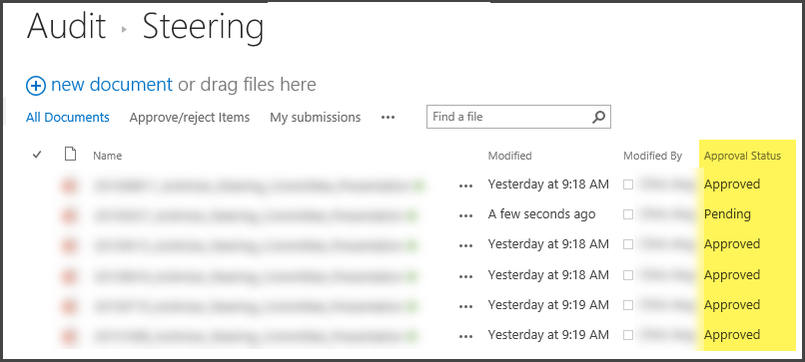

#### Suppress Version Creation

If a Find / Replace is performed and this option is enabled. Regardless if the list has versioning enabled, if this option is set to YES, no new version will be created after links are replaced. The most recent version found will be updated. If this option is set to NO, and one or more links are replaced, a new version is created for the list item (if versioning is enabled on the list).

NOTE: If this option is enabled, and “Preserve Author” option is also enabled, there will not be an audit trail of the changes in Version History for link replacements performed by the tool.

### Email (Optional)

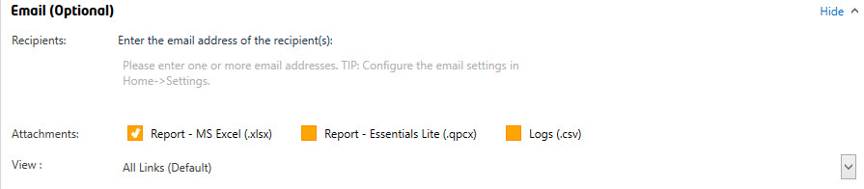

**Recipients**

You can optionally enter one or more email addresses for the users who you would like the report to be emailed to. Separate multiple email addresses with a semi-colon ‘;’. Once the report is completed, it will attempt to email the recipients found in this list.

TIP: Enter <Contact Email> for the email address to use the ‘Contact Email’ specified for the site in the Home Page Dashboard. For more information, see the “SharePoint Essentials Toolkit User Manual”.

**Attachments**

*Report - MS Excel (.xlsx)*   
Optionally include the MS Excel report as an attachment. This option is set to Yes (checked) by default. A custom View (see below) can be specified below to set custom filters and groupings to the MS Excel file that is emailed.

*Report – Essentials Lite (.qpcx)*   
Optionally include a SharePoint Essentials Lite report as an attachment. The client must have the SharePoint Essentials Lite Client (ClickOnce application) installed on their computer to open this type of report.

*Logs (.csv)*   
Optionally include the log files as an email attachment (they will be compressed/zipped).

**View** – (Only applies to MS Excel Report, not SharePoint List Exports or SharePoint Essentials Lite Client reports.) Select the view to use when creating the report. These views can be created from the Broken Links Report page (See Customizing the Report->Views for more information).

You can select a custom view from the drop-down list to apply it to the MS Excel file that is emailed to user(s). All grouping, sorting and filtering set in these views will be applied to the MS Excel report emailed. If you use the default view, the MS Excel will show a flat list without any grouping or filtering.

### Export Options (Optional)

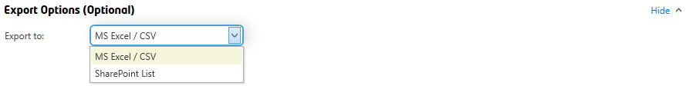

This allows you to choose how to export the report when the scan job completes. You can use the default ‘MS Excel / CSV’ or select ‘SharePoint List’ to export the report to SharePoint.

#### Export to SharePoint List

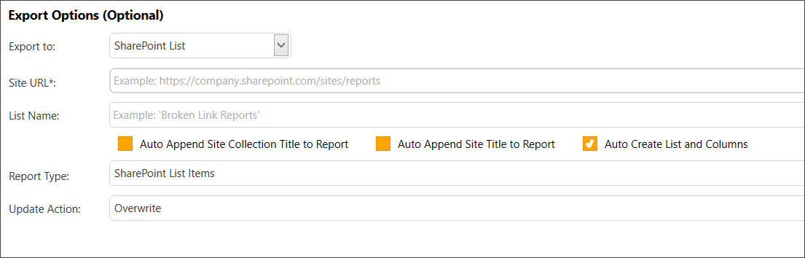

##### **Site URL**

This is the target Site URL where the report (SharePoint List) will be created.

If you select a Site URL from the drop-down list, it will use the existing credentials to export to that SharePoint Site.

If the access is denied (such as the current job is run on SharePoint 2016, however you are exporting to SharePoint Online), the tool will then attempt to use the credentials from the Export Site URL which were saved when the site was ‘Added’ to the Home Page Dashboard (“Remember Credentials”, during the Add Site process, option must have been selected for this to work).

<Current Site> - You can use this token / keyword to use the currently scanned site. If you have performed a ‘multi-threaded’ job by holding SHIFT or CTRL from Home Page Dashboard, this will export the report to the current site being scanned.

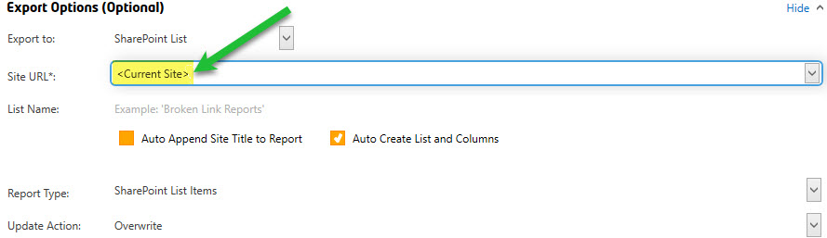

##### **List Name**

This is the List Title to be given to the List report. Do not use the List Internal name or URL.

##### **Auto Append Site Collection Title to Report**

This will automatically append the Site Collection Title to the end of the List Name. For example, if the List Name is set to ‘Broken Link Report’, and the Site Collection Title is ‘Information Technology’, the SharePoint List report that will be generated will be titled “Broken Link Report - Information Technology”.

##### **Auto Append Site Title to Report**

This will automatically append the Site Title to the end of the List Name. For example, if the List Name is set to ‘Broken Link Report’, and the Site Title is ‘Development Team, the SharePoint List report that will be generated will be titled “Broken Link Report - Development Team”.

##### ***Auto Create List and Columns***

This option is CHECKED by default and will automatically attempt to create the List and Columns. If the list already exists, it will attempt to create the list (only if the list does not exist) and recreate missing columns. If this option is UNCHECKED, it will not attempt to create the list or create the list columns. SharePoint Views that are created for the list are not overwritten when a report is generated/exported.

##### Report Type

You can choose to export the report to a SharePoint List as:

1. SharePoint List Items

NOTE: For reports with many Broken Links, this option may make the list a “Large List” of over 5000 items. If you have many Broken Links and do not want to reach this threshold, please use one of the other options below).

1. MS Excel File – The report will be uploaded as a MS Excel File.  
     
   NOTE: The options will change when you select MS Excel as export type.  
   See below:

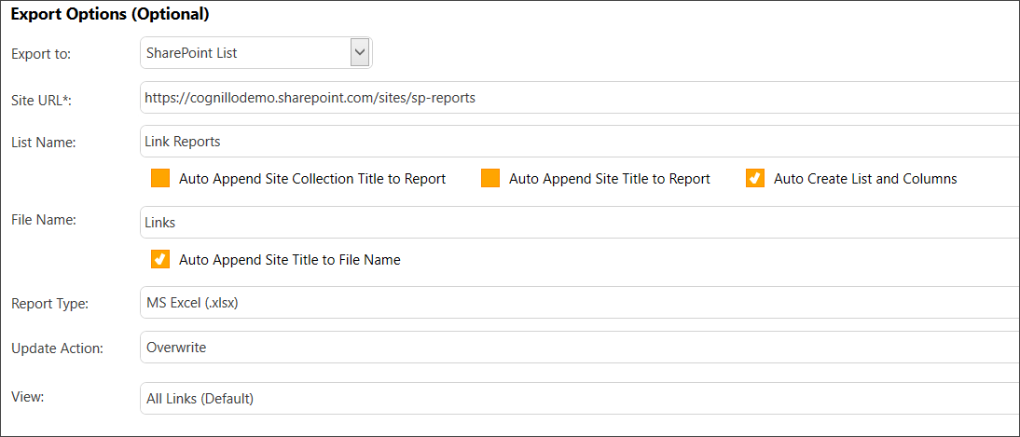  
**PRO TIP:** You can apply a ‘built-in’ or ‘custom’ View to the MS Excel report before it is exported. This is used to customize the reports being shared with end users.

1. QPCX File (SharePoint Essentials Lite Client format) – The report will be uploaded as a .qpcx file. This file type can be then opened by any end user who installs our free SharePoint Essentials Lite Client (WPF ClickOnce application).

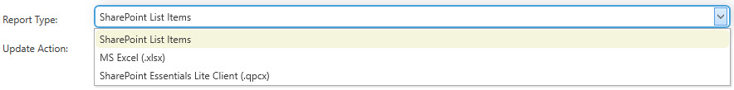

**NOTE:** If this job is targeting bulk sites (when creating reports against multiple site collections (by holding Shift/Ctrl from home page dashboard to create a report against multiple sites, see ***Batch Processing Jobs for Multiple Sites***): If ‘Auto Append Site Title to Report’ is turned on, the Site Title will be appended to the end of the name of the report automatically and a report will be created for each site scanned (multiple SharePoint Lists, one per site). If ‘Auto Append Site Title to Report’ is turned off, and you are exporting to a SharePoint List, all sites being scanned in the job will be merged into one single report (a single SharePoint List).

##### **Update Action**

1. **Overwrite**: This will first delete all SharePoint Items found (if list and items exist), then it will export the new report items to the list. The list will not be deleted so settings and views for the list remain intact.
2. **Append**: This will append report items to the list and if there are existing list items, they will remain intact and will not be overwritten or changed. If the “Report Type” is set to MS Excel or QPCX format, this option will append the new report by adding a date time stamp to the file name. You can turn off “Append” and turn on the library versioning to always show the most recent Permissions report and have old versions drop off based on the library major versions limit.
3. **Update**: (Available for SharePoint List Item Export) This will refresh the list of entries in the SharePoint Report for this site. If you are using a scheduled job for multiple sites that will add SharePoint List Items to the SAME SharePoint ‘Report’ List, you can use this option so that the report data is always ‘Updated’ for the site being reported on.

# What is a Broken Link?

## A broken link is a link that doesn't work, often resulting in an error page. A broken link happens when the link points to a web page that has been deleted or moved.

Each type of broken link can be categorized by a ‘Status Code’. These Status Codes are represented by numbers (“codes”) and can be translated to something ‘human readable’ such as 404 = “Page Not Found” 401 = “Unauthorized” 500 = “Internal Server Error” 403 = “Forbidden”, etc.

These Status Codes are provided from the web server when we try to ‘hit’ the URL, we do not create these codes.

A list of all possible ‘HTTP Status Codes’ can be found here:

<http://www.w3.org/Protocols/rfc2616/rfc2616-sec10.html>

<http://en.wikipedia.org/wiki/List_of_HTTP_status_codes>

## Manually Finding and Replacing Links

When a broken link is found, it will be listed in the report with a HTTP Status code, such as 404 (not found).

When a broken link is found, the user may right click on the item in grid view report and click “Open Item” to open the SharePoint item to edit/fix. The user can also click “Open Link” which will open the link in the default web browser to verify the issue.

**TIP:** Group report items by “HTTP Status Code” and “Item URL” to easily see the links that are broken.

# Find and Replace (Automatically Fix Links)

You may use the Find/Replace feature to automatically fix incorrect URLs.

For more information on the Find & Replace options in the tool, also please see the section Find & Replace Options

The tool will Find & Replace URLs that match the given text value you enter, regardless of the URL HTTP Status Code, in other words, the link could be valid or broken. If the value matches the input string you enter in ‘Old Value’, it will get replaced with the updated string/text entered in ‘New Value’.

For example: If you enter the following values

**Old Value:** <http://oldportalurl/sites/oldsitename>

**New Value:** <http://mynewportalurl/sites/newsitename>

And the tool finds a URL in a SharePoint page <http://oldportalurl/sites/oldsitename/Lists/Tasks/> it will update this link to become <http://mynewportalurl/sites/newsitename/Lists/Tasks/>

Below is a screenshot of the Find/Replace section in the tool, in this example below, I added 2 URLs to be replaced by the tool:

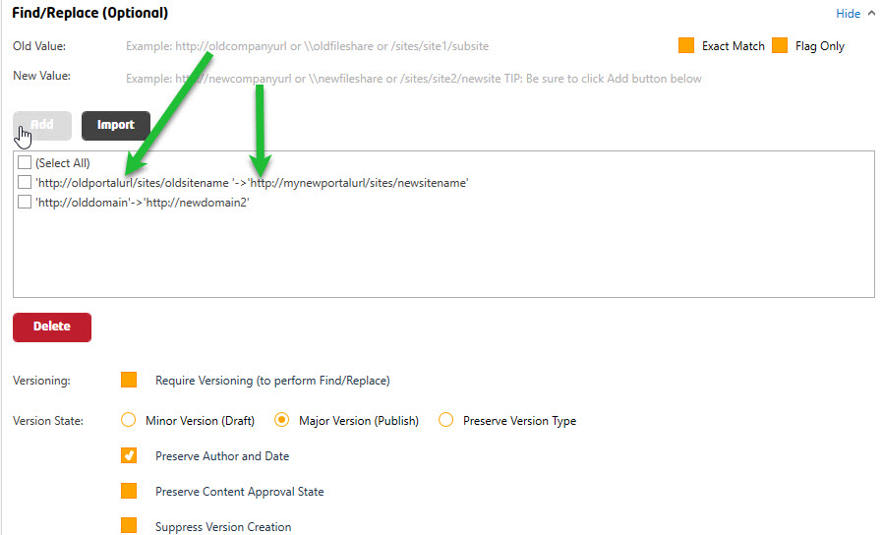

**IMPORTANT**: When adding Find/Replace URLs, you do **not** need to select/check any of the items. The checkbox below is only used if you are selecting a replacement rule to delete.

For more information on field options, please see the section Find & Replace Options

## What will be replaced

You can perform a Find/Replace by exact or partial match:

**Partial Match:** You can enter the text you want to match by putting that value in the “Old Value” text box, such as <http://oldportal>, or “oldserver”, or “/sites/” (if you want to update a managed path). The tool will find all matches contained anywhere in the URL and make all replacements for all occurrences of that text found in the URL. This is NOT case sensitive.

**Exact Match:** You can use an “Exact Match” to perform a find replace where the “Old Value” must be exactly equal to the URL found, otherwise it is not replaced. The OLD Value (old URL entered) match determination case sensitive.

### Supported Link Locations

URLs found in the following locations that match ‘Old Value’ will be replaced:

* SharePoint Lists
* SharePoint Document Libraries
* SharePoint Page Libraries
* SharePoint InfoPath Form Libraries and InfoPath forms
* Web Pages (such as in Wiki content zones, metadata, and web parts (see below for supported Web Parts))
* Document File Contents are supported for Find/Replace:
  + PDF (except ‘image-only’ PDFs such as hard copy documents scanned and did not use OCR to enable reading/searching of text data)
  + MS Word 97 and later
  + MS Excel 97 and later
  + MS PowerPoint 97 and later
  + MS OneNote 2003, 2007, 2010, 2013 (2016 not yet supported)
  + Txt, RTF, HTML, and other ASCII encoded file types
* Links behind friendly text such as “[Click Here](http://someurlpath.com/)” will be reported and replaced. “Click Here” would appear in the reports under the “HREF Display Text” column.
* URLs within link tags, such as the ‘href’ and ‘source’ tags, are replaced (if match is found)
* Links within ‘href’ display text are replaced (if match is found) (which are often the same as the URL text above)
* Link Description fields shown as ‘Title’ in anchor tags are replaced (if match is found) (which are often the same as the URL text above).
* Stub aspx pages when using ‘Send to Location’ and ‘leave a link’, these links are supported by Find / Replace
* Workflow Task Items with links for email alerts are supported by Find / Replace
* OOTB Web Parts:
  + The following OOTB web parts are supported and URLs within them will get replaced:
    - Script Editor Web Part
    - Xslt List View Web Part
    - Image Web Part
    - Page Viewer Web Part
    - Summary Links Web Part
    - Content Editor Web Part
  + Web Part Properties such as Title URL and JSLink URLs are supported by the tool and will be parsed for broken links.
  + NOTE: Content Editor web parts with linked/embedded files (such as when pointing the Content Editor web part to an html file (in web part properties) are scanned separately if the file is in the SharePoint site (in a list or library). Content Editor web parts with links typed directly into the web part area (‘Edit Web Part’) are scanned for links and replaced.

### Supported Link Types

* + Http, Https
  + FTP
  + File shares and UNC paths (such as “\\server\fileshare\folder1”)
  + Tooltips that contain hyperlinks
  + Descriptions or Alt URLs within hyperlinks

## Find/Replace Order

When you have multiple Find/Replace strings entered in the tool, the tool will attempt to match each string (“Old Value”), one at a time, in order from how you see it in the tool from Top going Down. If a match is found, it will attempt a replace (unless Flag Only is set). The tool will continue to go down this list of “Old Values” to match the string to the URL links found, regardless if there was already a match.

The product was designed this way in case you need to further manipulate a URL, you can add replacements for an absolute URL, which can get checked first, and then relative URLs such as a managed path, to get replaced after. As you may have instances of both in your environment.

We suggest adding in order of absolute URLs first and then relative URLs after so that you do not get unexpected results.

Example, you want to change from:

<http://companyold/subsite1/>

to

<https://companynew/sites/newsitelocation/>

### 1) WRONG WAY (some exceptions may apply)

[http:// companyold/subsite1/](http://dms.sharebox.dom1.intern/eepm_algemeen/) --> <https://companynew/sites/newsitelocation/>

Some exceptions may apply such as if you only want to fix absolute URLs and relative URLs are not a concern.

### 2) CORRECT WAY

* separate entries and
* remove trailing slashes at the end of domain/top host portion

[http:// companyold](http://dms.sharebox.dom1.intern)  -->  <https://companynew.sharepoint.com>

/subsite1/  -->   /sites/newsitelocation/

The reason is because many links in SharePoint are relative, so if you use the first method, then it will not match any ‘relative’ links that start with ‘/’

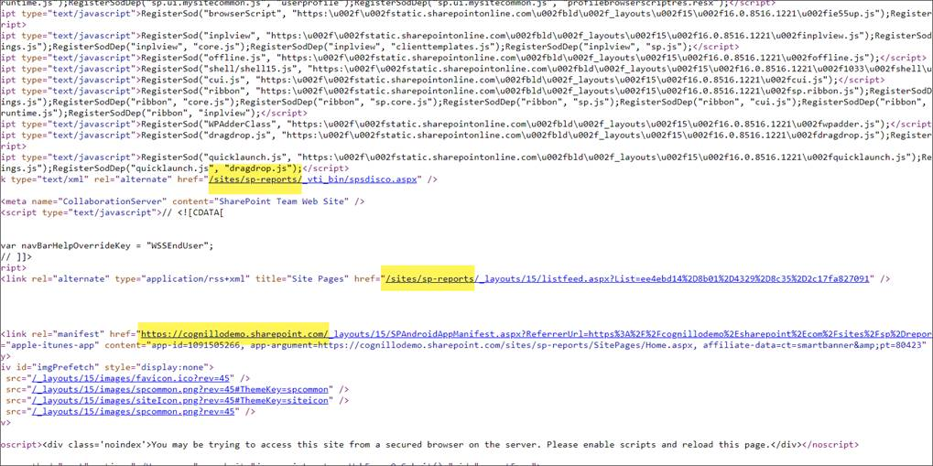

## What will NOT be replaced

* Text based links in MS Office files (such as URLs that are present in a web page or document (as text), but do not show a **hyperlink tooltip** when you hover mouse over them) are not supported by Find/Replace.

**Example of ‘text based’ link:**

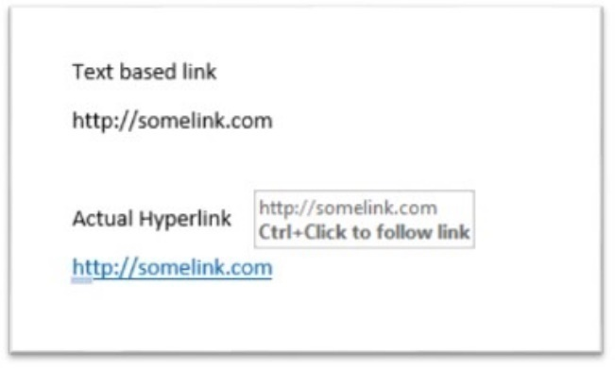

* URLs in User Profile pages (metadata), such as Skills, Description, will not be scanned or replaced by this tool. Currently User Profile metadata is not supported, but SharePoint Libraries in My Sites (and OneDrive) are supported.
* Items that are checked out to another user will not be updated and therefore any matching URLs within them will not be replaced. There will be an error in the logs that shows the file is checked out to another user and will not be updated. If the file is checked out to the current logged in user (running the scan), the file will get updated (Find/Replace will be executed) and the file will be checked-in appropriately depending on the ‘Check In type’ setting. **It is recommended to have all files Checked-In prior to running the Find/Replace Job. You can use “Item Query” to build a report on Checked Out files.**
* MS Excel: URLs in Visual Basic Code will not be replaced.
* MS Excel: URLs added when user clicks Data->Get Data, see below

  
The tool will not report on MS Excel data linked this way, nor can it fix these types of links (embedded data).

* Find/Replace URLs in External Lists are not supported
* Web parts that have a URL which are not hyperlinks (such as plain text URLs that are not clickable links) are not supported.

## How the tool creates versions

If versioning is enabled on the List or Library that the Find / Replace occurred, a comment is added in the Version Comments for the item/file/page.



If versioning is NOT enabled on the List or Library that the Find / Replace occurred, a comment is added in the ‘Check In Comment’ field.

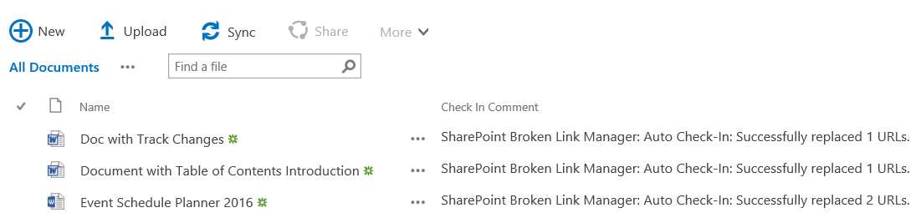

## Preserve Author and Date

If you enable “Preserve Author and Date” in the tool settings, the ‘Last Modified By’ and ‘Last Modified Date’ will be kept for files that are updated by Find/Replace.

**NOTE:** If Minor versions are enabled on the list, and you choose to ‘Check-In’ Find/Replace changes as a Major Version (Publish), with ‘Preserve Author and Date’ set, the version will be incremented once as the Major version, such as version 3.0. This new Major version will have the Find/Replace changes. It will then check-in the item and set the original Author information, showing an extra minor version (in order to display the last modified info), such as version 3.1; this is by design.

If you choose to Check-In Find/Replace changes as a Minor Version (Draft), and also set ‘Preserve Author’, the version will be incremented once as the Minor version, such as version 0.2 (if the original version is 0.1), this new minor version will have the Find/Replace changes; then it will check-in the item and set the original Author info, this then shows as an extra minor version (in order to display the last modified info), such as version 0.3, this is by design.

Enabling the option ‘Suppress Version Creation’ (introduced in v6.4.0.0) will make the tool not create a new version after one or more Find/Replacements occur, even if Preserve Author is enabled.

### Limitations / Permission Requirements

Preserve Author and Date will only work if the account used to run the tool has Full Control on the site.

The item will retain the version for the previous Author (if versioning is enabled), however, the tool is forced to perform a Check Out and Check In to perform the update (Find/Replace), then Check Out and Check In to set/preserve the original Author info.

## Preserve Content Approval State & Find/Replace

If Preserve Content Approval State is turned on in the list, and if the item is updated (during Find/Replace), the Approval Status will set to “Pending” again. An Approver will need to approve the document again, there will be a comment when it is checked-in “Automatic Check In – SharePoint Broken Link Manager Find/Replace”.

## Versioning

If “Require Versioning (to perform Find/Replace)” is enabled on the library, a new version is created for the file automatically with a comment indicating the tool has performed a Find/Replace.

NOTE: See Preserve Author and Date section on how to keep “Last Modified By” and “Last Modified” metadata after a Find/Replace.

The tool will check the most recent version of an item/file/page for links, not Version History.

### Older Versions / URLs in Version History

The tool will NOT attempt to perform a Find/Replace on any items in the version history except the most recent version of the file.

Minor Version (Draft) and Major Version (Publish)  
When performing a Find & Replace, the tool will modify the most recent ‘Published’ Major or Minor version it has access to. If the tool account used has permission to Edit a draft version, and the Draft version is the most recent version of the file, the tool will perform the Find & Replace on the draft version and will Check-In the Item as a Major or Minor version, depending on the setting used in the tool. If the Item has only a Major version as the most recent version, it will perform a Find & Replace on that Major Version (Publish) and Check-In accordingly.

Version State   
For more information on this option, please see the section Find & Replace Options

### Check In & Check Out

* As mentioned in ‘What will NOT be replaced” (when using Find/Replace): Items that are checked out to another user will not be updated and therefore any matching URLs within them will not be replaced. There will be an error in the logs that shows the file is checked out to another user and will not be updated. If the file is checked out to the current logged in user (running the scan), the file will get updated (Find/Replace will be executed) and the file will be checked-in appropriately depending on the ‘Check In’ type setting.
* It is recommended to have all files Checked-In prior to running the Find/Replace Job to do all replacements found. NOTE: You can use Item Query (part of Content Manager) to build a report on all Checked Out items/files.
* If versioning is enabled on the library, and it has Major and Minor versions enabled, you have the option to Check-In as Minor Version (Draft) or as a Major Version (Published) or Preserve Version Type.

### **Number of Versions created after a Find/Replace:**

Find / Replace will create 2 versions by default. The tool will create a single (1) new version (if versioning is enabled on the List) regardless if 'Preserve Author' is selected, and an extra version if ‘Preserve Author is enabled (this is ON by default).

The tool will create an additional version if Content Approval is turned and the user chooses to “Preserve Content Approval State”.

The tool will create a new version for Find/Replace of metadata and also a new version if file content was changed (a Find/Replace occurred). An additional minor version is also created for a total of 4 versions **if the metadata, and file content have URLs to fix**, and ‘Preserve Author’ is enabled. If the List only has Major versions enabled, 2 new versions are created for the above scenario.

Preserve Version Type   
If a Find and Replace match is found, the tool will check the current version of the item (check the version number and determine if it is a major or minor version, such as 2.3 which would be minor, or 3.0 if it was a major version), perform the Find and Replace and it will save the updated item as the same version type as it was originally. This way, if the item was in Draft state and was in the middle of changes, it will not be published as the Version Type will be kept (such as 2.4 for minor or increment to 4.0 for major version type).

If the file is checked out to a different user than the tool is running as, the item/file will not be updated and will not be checked in, you will see a warning in the Active Logs.

Example if **Preserve Version Type** is enabled:

**Original File**

File1.docx v0.3 (Minor)

File2.docx v3.0 (Major)

**After Find Replace**

File1.docx v0.4 (Minor is preserved)

File2.docx v4.0 (Major is preserved)

### SharePoint Publishing Pages & Preserve Author (Option)

Note that when fixing links in SharePoint Publishing Pages (for both SPO and SP on-premises), if you choose both of these options:

* "Preserve Author" (enabled by default)
* AND "Major Version (Publish)" or "Preserve Version Type"

Pages **will be Published** (if they were previously in 'Published' state for "Preserve Version Type") but will remain as Draft to retain the 'Last Modified Information'.

This is due to a Microsoft limitation similar to not being allowed to "Approve" as someone else when preserving "Content Approval State", the tool is not able to Publish as another user (due to restrictions set by Microsoft to prevent impersonating another user to publish or approve documents).

The new URLs will be visible to all users (as the page is published), however it is then set to Draft state to "Preserve Author". User's / Content Owners will need to click "Publish this draft".

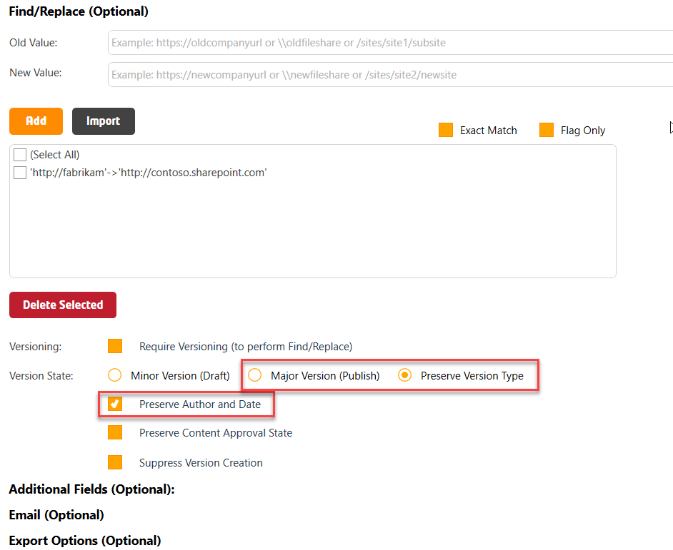

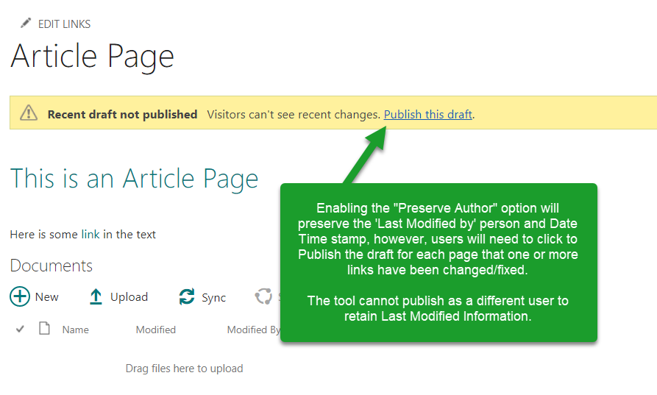

### Import Find/Replace Links (in bulk)

You may import from a MS Excel file a list of URL replacements to use. This can be handy if you have multiple sites and want to have Site Owners send you MS Excel files with fixes to the URLs.

To do this,

1. Create a MS Excel file that has two columns, ‘Old Value’ and ‘New Value’. The ‘Old Value’ will store the old value to be replaced, the ‘New Value’ will be the new URL to replace the ‘old value’ with. Enter the old URLs and New URLs that will be replaced. You do not need to use column headers in the Excel file when importing.

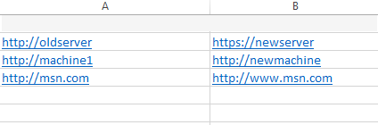

1. Click “Import” from the Find/Replace section.

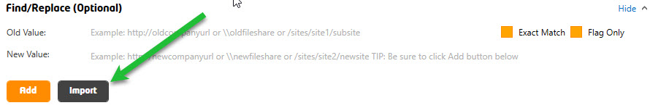

1. A “File Upload” pop up window will appear, browse and select the MS Excel file and click “Upload”.

The entries will now be imported and listed in the Find/Replace list box.

## Fixing Links from a File Share Migration

See this [article](https://cognillo.atlassian.net/plugins/servlet/servicedesk/customer/confluence/shim/spaces/CS/pages/10813596/How+to+Fix+Broken+Links+from+a+File+Share+Migration) for help with fixing links after a File Share Migration to SharePoint

## Find/Replace Options

See this section for [Find / Replace Options](#_Find/Replace_(Optional))

## Using Regular Expressions to Find/Replace links (i.e. Copy Link or Document ID links)

Starting with the SharePoint Essentials Toolkit version 9.8.6.0 (recommend to use 10.1.2.0 as it applies certain fixes for this functionality), the tool supports Regular Expressions to match patterns in a URL, such as query strings used for the Document ID service and/or Durable Links that use ?d=<guid> patterns in the URL.

See [How to use Regular Expressions to find and fix links (such as Document ID service links or Durable Links)?](https://cognillo.atlassian.net/plugins/servlet/servicedesk/customer/confluence/shim/spaces/CS/pages/2022539265)

## Link Report - Finding URLs that were automatically replaced/fixed

All URLs matched with a ‘Find/Replace’ ‘Old Value’ will have an HTTP Status Code with * appended to the end of it, such as 200* or 404*.

You can use a ‘built-in’ view called “Validate Find Replace” to only show links that have been replaced by the tool:

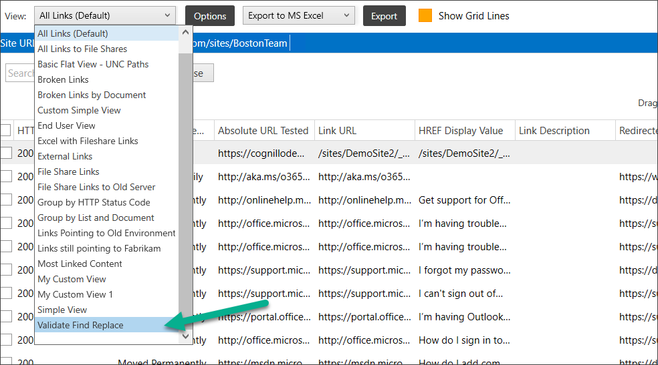

There is a column labelled “New Link URL”, this field will be populated when a link is replaced, you can group, sort or filter by this column to quickly find updated documents that had URLs fixed/replaced.

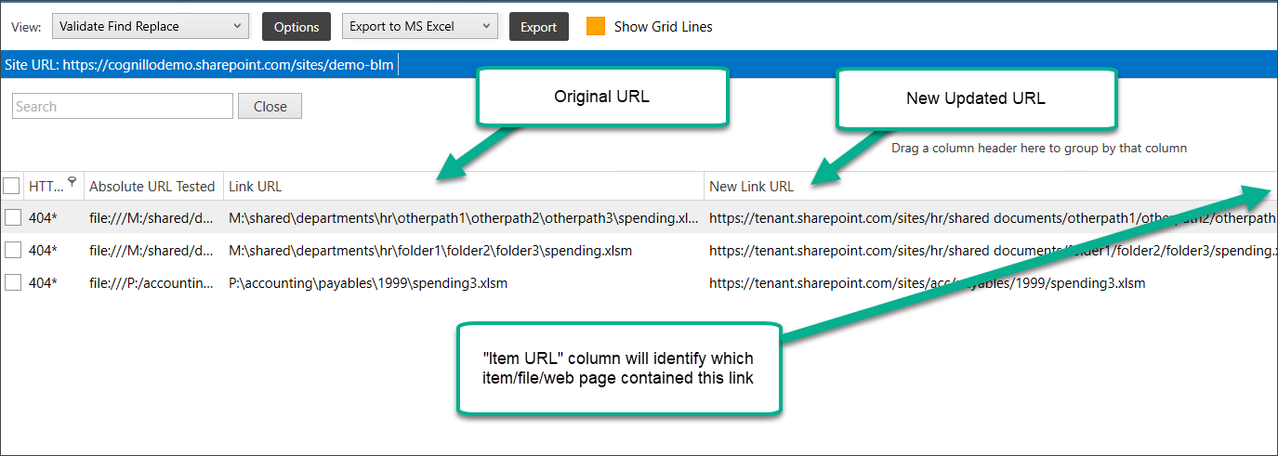

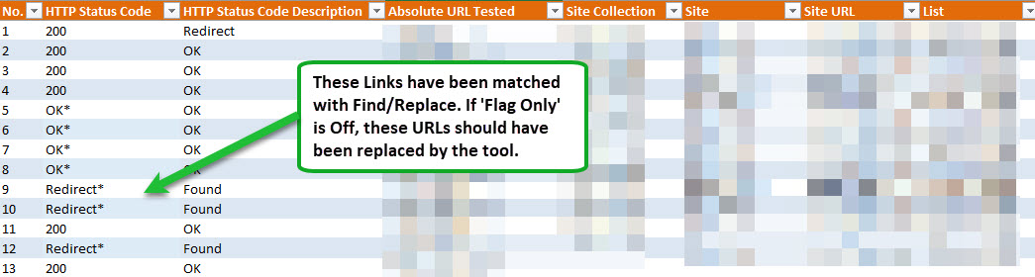

## How to find all Links that matched Find/Replace but were not replaced?

Some links cannot be replaced by the tool, such as Copy Source field links, as this field is a read-only field and cannot be modified by the tool.

Links such as these which might be matched by the Find/Replace string, but not replaced, will usually show a warning or error message in the logs, for example:

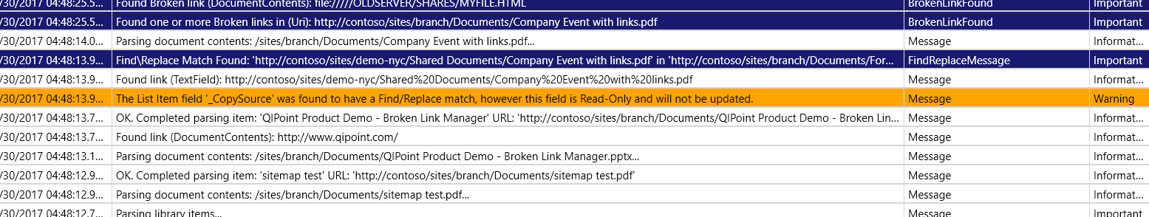

TIP: You can press CTRL+F to bring up search box to search logs for any files (by filename) that may have not replaced correctly.

Also, in the report, all links that were matched but not replaced will have an asterisk next to the HTTP Status Code **and** will have a blank value for the ‘New Link URL’ ‘New HREF Display Value’ and ‘New Link Description’ columns, such as below:

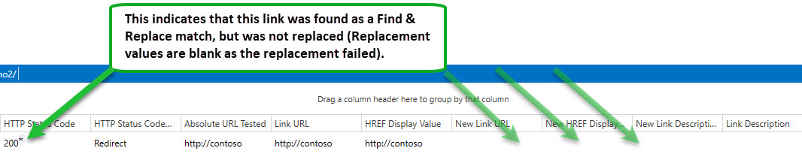

A common issue for Find / Replace not working, is that you have enabled ‘Require Versioning (to perform Find & Replace)’ in the Find / Replace options but the List that the file/item/page belongs to does not have versioning enabled.

# Scheduling Jobs

This product includes a built-in scheduler which allows you to scan sites on a schedule. Scheduled jobs run faster than jobs manually run as they do not have to write logs to the UI (user interface).

**TIP:** Ensure the “SharePoint Essentials Service” (Windows Service) is running before trying to schedule a job. Ensure the user account used to run the service has ‘Modify’ permission to the Report Path (Home->Settings). By default, this service uses ‘Local System’ which may not have rights to create files (reports) in a network file share for example.

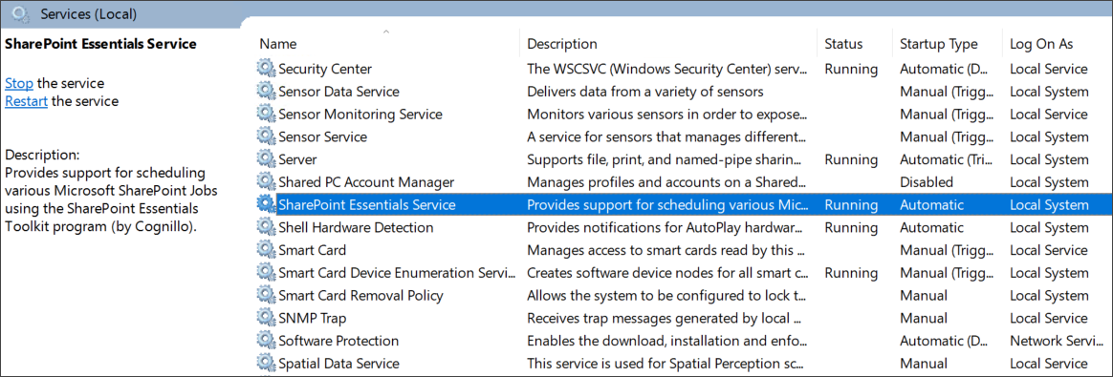

## Schedule a Job

Once you complete the General Job Information and Scan Options sections, click the “Schedule Job” button to schedule the job. A “Scheduler” window will appear to set the date and time, recurrence and expiration of the scan job.

P860#yIS1

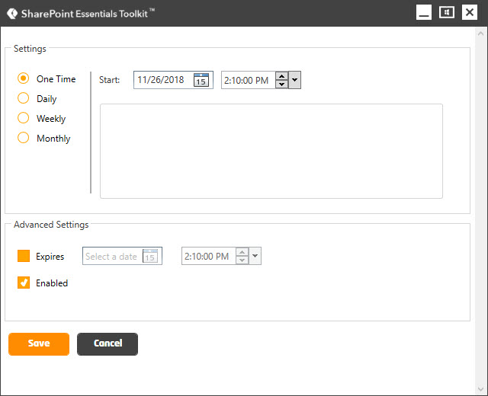

Select the schedule and specific options, and then click “Save” to schedule the job.

## List of Scheduled Jobs

You can view all scheduled jobs and their status’ by clicking on “Scheduled Jobs” from the Jobs section.

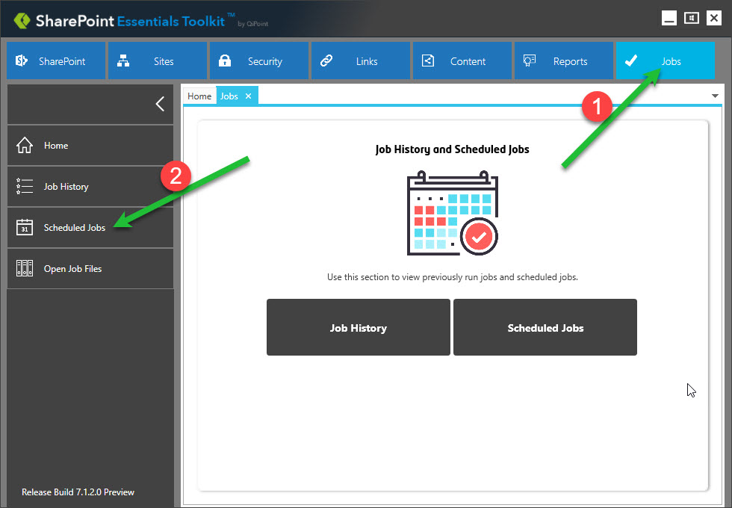

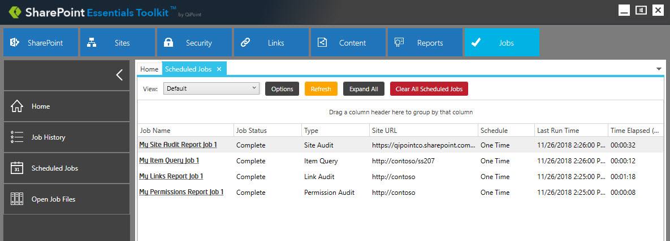

From here you can view reports, logs, execute the job, modify or delete scheduled jobs (by right clicking the job).

## Scheduled Job Logs and Reports

After a successful Scheduled Job, right click on the job to view the log or the actual report; re-edit, re-run, delete or even add a new job. You can also access logs and reports from the Home Page Dashboard, as well as from the Job History section of the tool.

NOTE: Only applicable reports and logs will be shown.

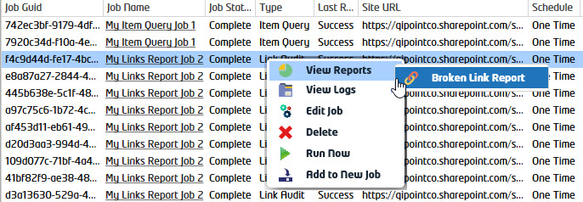

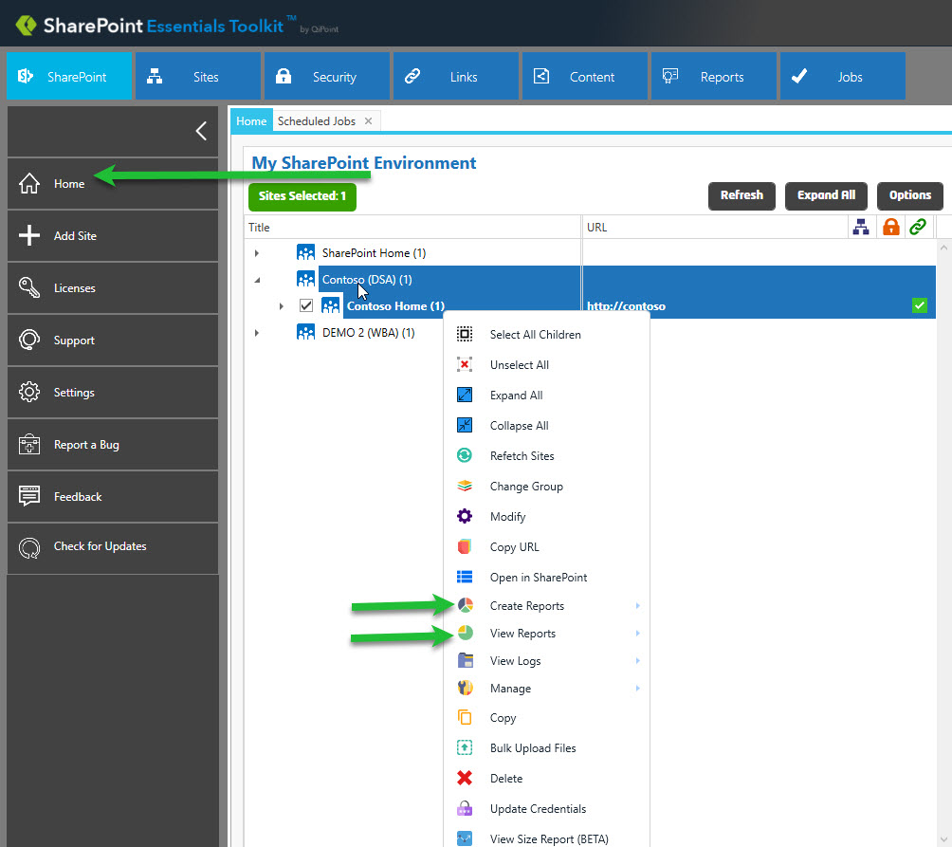

# Batch Processing Multiple Site Collections

You can create a job to report against multiple site collections from the Home Page Dashboard by selecting multiple sites and right clicking. See SharePoint Essentials Toolkit (User Manual) -> Batch Processing Reports for Multiple Sites for more information.

# Logs

As the Job is running, logs will be generated in real-time so that you can view the status and progress.

## Viewing Job Logs

Log files and reports are stored under ‘Jobs->Job History. The physical CSV files can also be obtained by going to the path located in the Settings page (Home -> Settings -> Path to Store Reports). The logs have ‘logs’ appended to the end of the file name.

Normally you can view any log by navigating to the Home Page Dashboard, and right clicking the site you ran the job, and then clicking “View Logs”. You can also view logs from the “Job -> Job History” page.

If the job was scheduled, the logs are accessible from the “Jobs->Scheduled Jobs” window and will also show in the Job History once they run.

Below is an example of the “Active Logs” page for a manually, run job (not scheduled). Broken Links will show up with a navy-blue background when detected. A similar log window will appear when viewing jobs from the “Job History” window or the “Scheduled Jobs” pages.

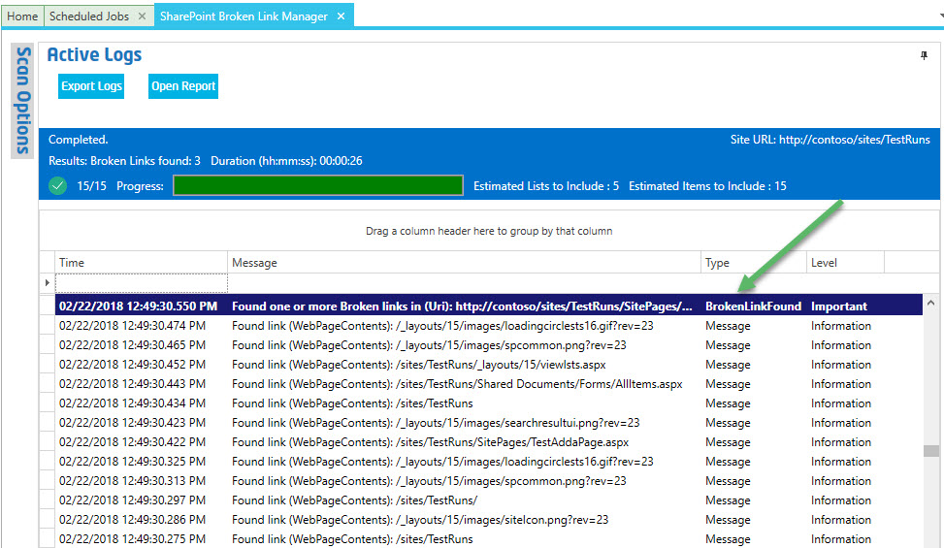

## Exporting and Sharing Logs

You can export job logs to CSV format by clicking the “Export Logs” button.

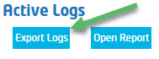

NOTE: In some cases, the CSV files do not display the Date Time correctly. The log date and time may appear as a number. In this case, you need to save the CSV file as MS Excel and then format the Cells in the first column to display the Date Time value correctly.

# How to Interpret the Report

### Example

Here is an example of a page with 2 broken links:

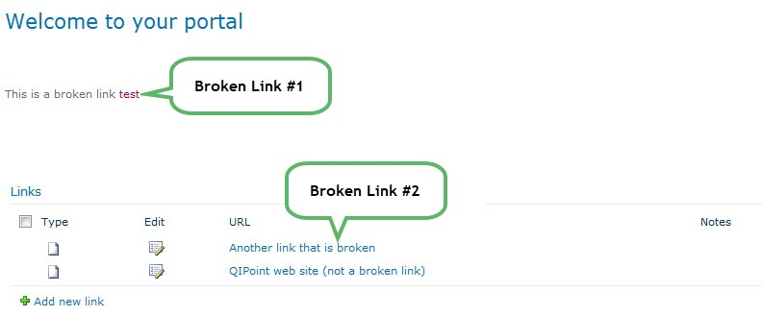

In the grid and in the exported report you will see the 2 broken links found, along with each link’s location.

### Which Links Are Broken?

Within the Active Logs window, click the “Open Report” button.

The column labelled “HTTP Status Code” is the column which will tell you if the link is broken or not. “HTTP Status Code Description” will also give a description of the response from the server when resolving a URL. Generally, an HTTP Status Code of 200 means the link is valid and reachable, anything else could mean a broken link (but not always the case).

See the following sources for more information on the HTTP Status Codes and how to interpret them:

<http://en.wikipedia.org/wiki/List_of_HTTP_status_codes>

<http://www.w3.org/Protocols/rfc2616/rfc2616-sec10.html>

See also the ‘Report Fields’ section below. The section provides information about columns in the report and how to validate and find the links in your environment.

#### Views

You can use one of the built-in views to view only the Broken Links for the site:

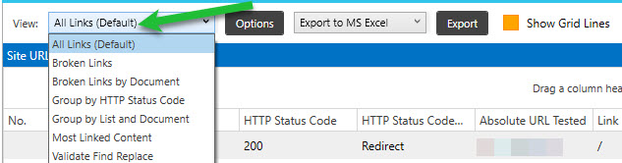

#### Only Show Broken Links in Report

There is an option in the Scan Options page to only show broken links in the report. You can select this option to filter all valid links. However, sometimes it is useful to see all links to help with validation.

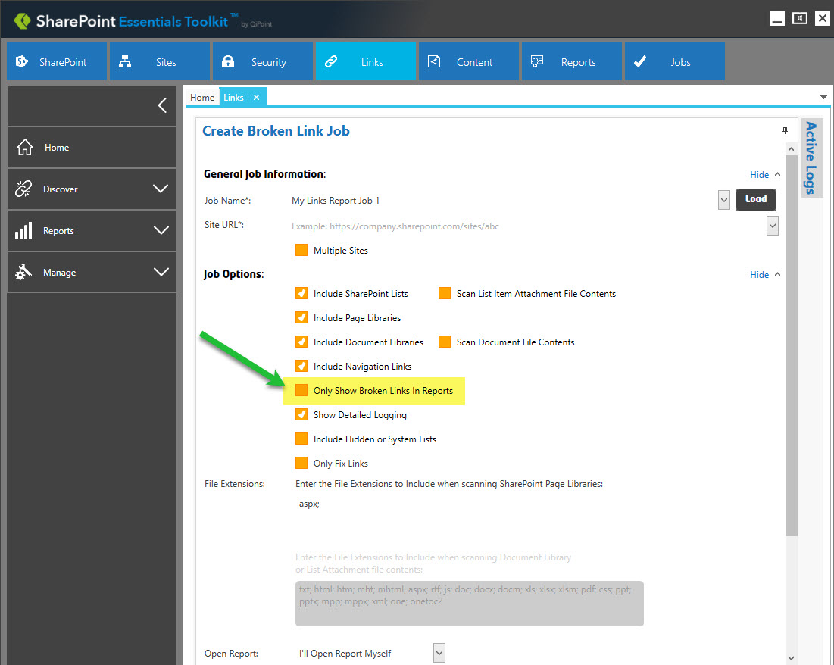

# Reports

## Opening the Report

Once a scan is complete, you can open the report in several ways:

* + When a scan is complete, you will have a button on the top right (above the “Active Log”) that says, “Open Report”.

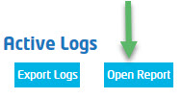

* + Once you click “Open Report” and the report opens, you can click “Export” to view the report in SharePoint/CSV/PDF/Excel/QPCX format.

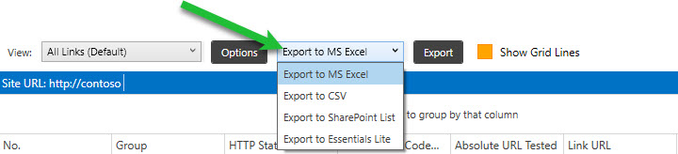

* + From the Home Page Dashboard, right click on a site that you wish to preview, and then click “View Reports -> Broken Link”.

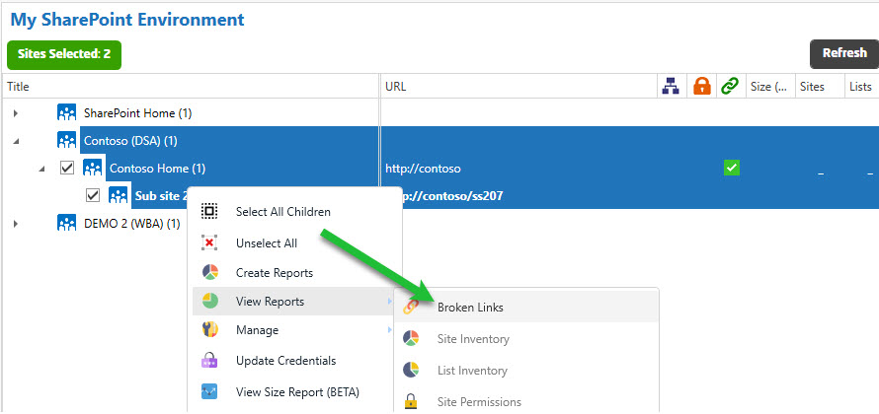

* + From the “Job -> Job History” page, locate the previously run Broken Link jobs and their reports and logs.
  + For scheduled jobs, you can also find the reports and logs under the “Job -> Scheduled Jobs” page.
  + To view all report files (CSV and QPCX formats available)
    - Open Windows Explorer and then navigate to the path where the reports are stored. By default, the user’s My Documents (or Documents) folder stores all report files under “SPEssentials\Reports”. Change the report path under “Home -> Settings -> Path to Store Reports” (if necessary).

## Report Fields

#### *No.*

Line number. This is used as a reference to help identify items that need to be responded to as they are reviewed. This is not related to the actual link and is for reference purposes only.

#### *Group*

This is the group name that was given to the site during the scan. This does not affect SharePoint data; it is only used for reporting purposes. For example, you can set the name of sites to “Production” or “Test” for different environments.

#### *HTTP Status Code*

This is the code response from the server when testing for the broken link. Such as 404. If Find/Replace was used, this value will be prefixed with a ‘*’ (such as *404 or *200) to identify this record as matching the Find/Replace value.

#### *HTTP Status Code Description*

This is the descriptive response from the server when testing for the broken link. Such as “Not Found”

#### *Absolute URL Tested*

The actual URL that the utility scanned to check for a broken link. If the link detected was a relative path, such as a web page with “/sites/site1/Lists/MyList”, the tool will automatically try to determine the absolute URL that the link would normally resolve to if the user clicks on it. If the relative link above was in <http://contoso/>, the Absolute URL Tested would be <http://contoso/sites/site1/Lists/MyList>. Another example of a relative link is ‘../../../Style Library/custom1.css’, this will translate to a path that will be calculated using our proprietary link algorithm to determine the actual SharePoint path that would be used to reach the link. The absolute URL tested may be something like this ‘<http://contoso/Style%20Library/custom1.css>’.

#### *Link URL*

The ‘actual’ URL of the link that was found. This is the actual link that you can search for within a page, item or file that you are validating.

#### *HREF Display Value*

This is the text that is displayed to the user in the broken link, it would link to the ‘broken link’. In web pages, this is the text within an Anchor tag, such as <a href=<http://contoso>>HREF Display Value</a>.

#### *Link Description*

In web pages, the ‘Title’ field in the Anchor tag is this value, such as <a href=<http://contoso>>HREF Display Value</a>. In MS Office documents, this is the “Screen Tip Text” value.

#### *Site Collection*

The title of the Site Collection that the scanned link belongs to.

#### *Site*

The title of the Site that was scanned.

#### *Site URL*

The URL of the SharePoint site that the link was found in.

#### *List*

The title of the SharePoint List that the link was found in.

#### *List URL*

The URL of the SharePoint List that the link was found in.

#### *Field*

The field name that the broken link was found in, for example, you may have a custom column called “Company Web Site” or “Description”.

#### *Link Type*

The type of broken link. Such as within “Document Contents”, “HTML field”, “Note Field”, “Content Editor Web Part”, etc.

The following is a list of the possible link types:

* WebPageContents = Link within web page content
* DocumentContents = Link within a document
* DocumentContentsExcelFormula = Link within Excel Formula or Excel External Link
* DocumentContentsExcelMacro = Link within Excel Macro / Visual Basic Code
* DocumentContentsFromItemAttachment = Link within contents of a document that is a List Item Attachment
* DocumentContentsOneNoteSection = Link within OneNote document
* HtmlField = Link within SharePoint Column that is of type Html Field
* PublishingHyperlink = Link within SharePoint Column that is of type PublishingHyperlink Field
* TextField = Link within SharePoint Column that is of type Text Field
* NoteField = Link within SharePoint Column that is of type Note Field
* LinkField = Link within SharePoint Column that is of type Link Field
* SummaryLinkField = Link within SharePoint Column that is of type Summary Field
* SummaryLinkWebPart = Link within a Summary Link Web Part
* ListViewWebPart = Link within a List View Web Part
* ContentEditorWebPart = Link within a Content Editor Web Part
* ScriptEditorWebPart = Link within a Script Editor Web Part
* ImageViewerWebpart = Link within an Image Viewer Web Part
* PageViewerWebpart = Link within a Page Viewer Web Part
* SearchBoxWebPart = Link within a Search Box Web Part
* ContentSearchWebPart = Link within a Content Search Web Part
* XMLWebPart = Link within a XML Web Part
* ResultScriptWebPart = Link within a Result Script Web Part
* RSSViewerWebPart = Link within a RSS Viewer Web Part
* ContentByQueryWebPart = Link within a Content by Query Web Part
* SiteAggregatorWebPart = Link within a Site Aggregator Web Part
* NoteBoardWebPart = Link within a Note Board Web Part
* QuickLinksWebPart = Link within a Quick Links Web Part
* SiteNavigation = Link within the Site Navigation
* DocIDService = Link found in the Document ID field
* QuickLaunch = Link within the Quick Launch navigation
* TopNavigation = Link within the Top Navigation
* MetadataNavigation = Link within Managed Metadata Navigation
* SiteLogoURL = Link for the SharePoint Site Logo
* LinkedCSS = Link for a referenced CSS (Cascading Style Sheet) file
* LinkedJS = Link for a referenced JavaScript file

#### *Item Unique ID*

The unique ID (GUID) of the SharePoint item that the broken link was found in. This GUID value is used when a user wishes to “Only Fix Links” for specific files/items/web pages.

#### *Item Title*

The title of the item that the broken link was found in.

#### *Item URL*

The item URL that the broken link was found in.

#### *List Item URL*

The item URL that the SharePoint list was found in.

#### *New Link URL*

If Find/Replace was used, and a match was found, this is the new value for the Link Url that was updated in the document. If Find/Replace was used, and it was set to “Flag Only”, the flagged match will appear in this column and no data will be modified.

#### *New HREF Display*

If Find/Replace was used, and a match was found, this is the new value for the “HREF Display Value”. This would occur if the URL and HREF Display description are both URL values that match Find/Replace criteria. If Find/Replace was used, and it was set to “Flag Only”, the flagged match will appear in this column and no data will be modified.

#### *New Link Description*

If Find/Replace was used, and a match was found, this is the new value for “Link Description”. This would occur if the URL and HREF Display description are both URL values that match Find/Replace criteria. If Find/Replace was used, and it was set to “Flag Only”, the flagged match will appear in this column and no data will be modified.

Site Owner  
If the Site has the default “Owners” group, this column will display the names of the members of this group.

Author  
This is the author of the item (where the URL was found).

Last Modified  
This is the date and time the item (where the URL was found) was last modified.

#### *Last Modified By*

This is the user who last modified the item (where the URL was found).

## Report Archive

When a report is created and there is a report that already exists for that scan (this occurs if it is the same site URL that is scanned and on the same day), the old report (and the related log file) will be renamed and moved to a folder called “Archive” in the same directory. The new report will then be created.

## Grid View Report

Reports are optionally viewed with Grid Lines if the “Show Grid Lines” checkbox is manually marked. ~~This Grid View allows the user to drag and drop columns, sort, and apply advanced or simple filtering to help to generate a report most useful for them. For example, they can group to view all broken links within a specific document, or search and sort to find common broken links across lists and sites.~~

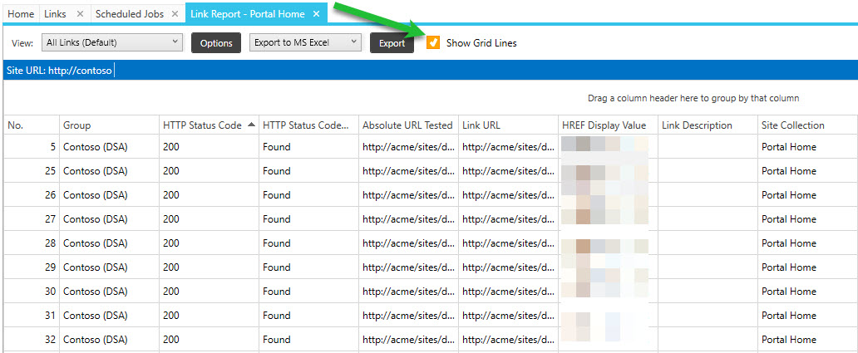

## Customizing the Report

You can filter, sort and group the results from the scan job, for example, by placing your mouse over the column header and then right-clicking on the column.

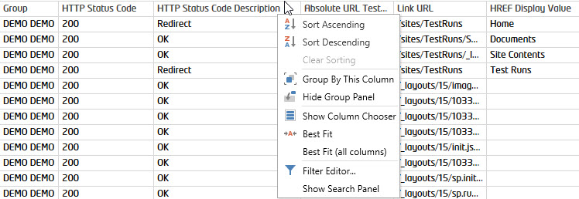

### Filtering

To filter the data based on a field, put your mouse over the column header that you want to filter by. You should see a filter icon, select it and choose the values you only want to have shown in the grid.

### Advanced Filtering

To filter the data based on a field using advanced criteria, right click on the column header and select “Filter Editor”. You can now add criteria to filter the results.

### Searching within the Report

Right Click on any column header and select “Show Search Panel”. The search panel appears and you can enter any value to search the grid, results will be highlighted.

### Filtering Queries

You may also filter the report by using queries. Right click the column header and select “Filter Editor” to add criteria to filter the results

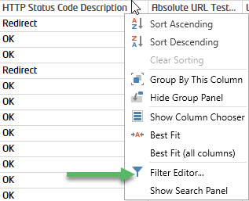

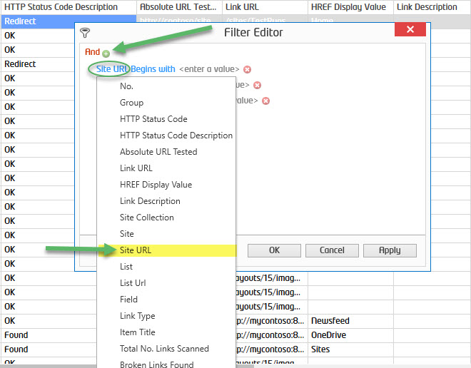

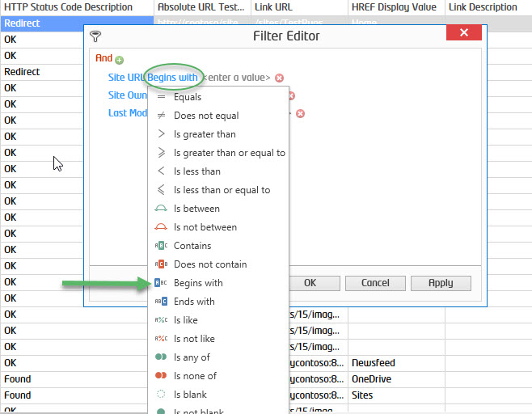

### Grouping

To group the results, drag the column header of the field you want to group by to the top of the results panel. You can also drag multiple panels and rearrange the group ordering by dragging columns left and right of each other

Below I grouped by “List” and “Item Title”, so here I can see all links found under the “Home.aspx” page:

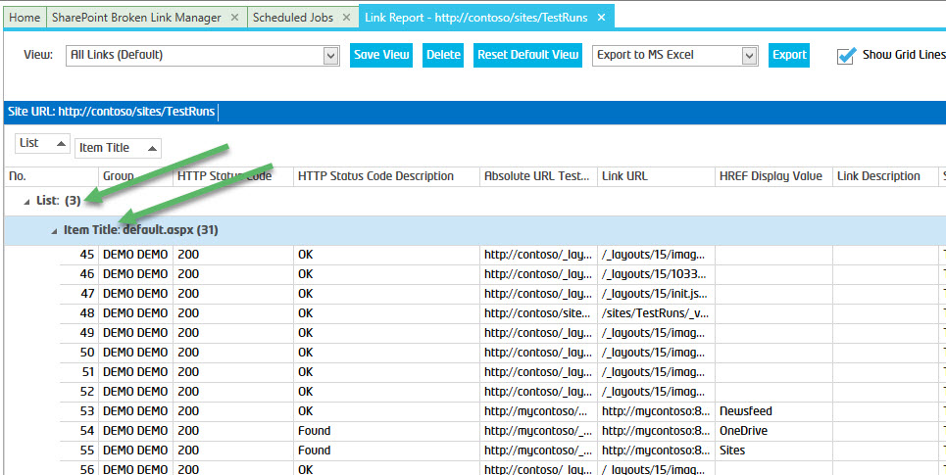

### Views

The user can save views or modify the default view by clicking “Save View”. A view can be deleted by clicking “Delete”, the user will be prompted to delete the current view. The Default view cannot be deleted. “Reset Default View” will reset the Default view to the ‘out of the box’ view.

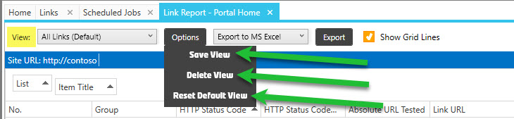

### Export

A report can be exported to the following formats directly:

1. MS Excel
2. CSV
3. SharePoint List
   1. As SharePoint List Items
   2. Uploaded as MS Excel File
   3. Uploaded as QPCX File (SharePoint Essentials Lite Client)
4. Essentials Lite (QPCX/SharePoint Essentials Lite Client)

To perform the export, select the option in the drop down and then by clicking the “Export” link. Alternatively, multiple rows can be highlighted and ‘Copied’ by right clicking and selecting “Copy”. Then the selected rows can be pasted in MS Excel, an Email, MS Word or any compatible program.

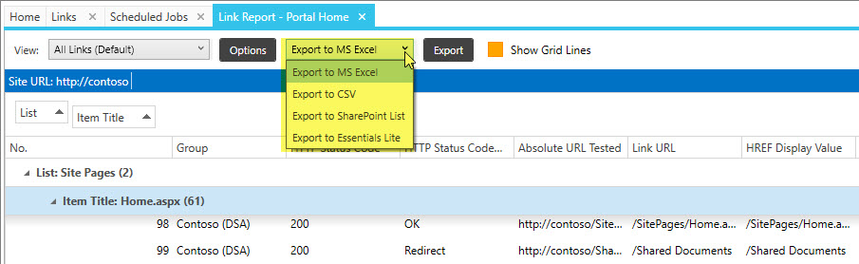

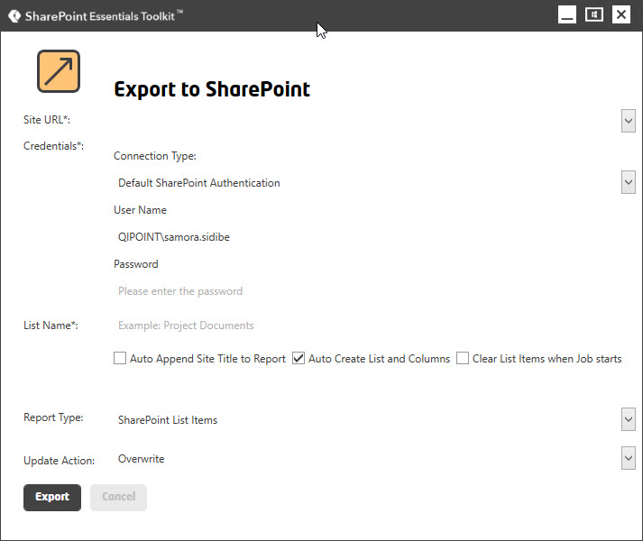

# Best Practices: Improving performance and Large Scan Jobs

For scanning environments with over 500,000 links or over 200GB data in a scan job/project, we recommend the following:

* See SharePoint Essentials Toolkit documentation for “Import Multiple Sites to Dashboard” to bulk import sites to the home page dashboard.
* Turn OFF/uncheck “Show Detailed Logging” – this prevents logging of ‘verbose’ information to UI and log file.
* If you do NOT need to validate the links, or have already validated which links are broken and only need to fix links, or only need an inventory of all links, select ‘Skip Validation of Links’ (this was labelled ‘Only Fix Links’ in version 7)  
    
  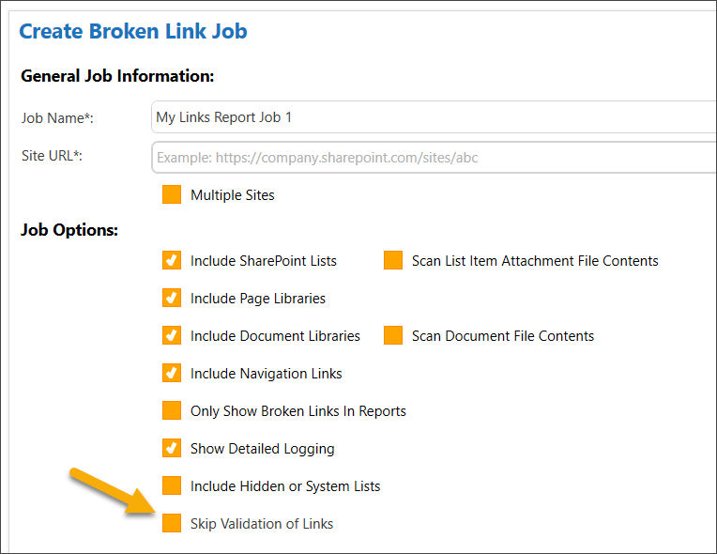
* Split scan job into multiple jobs and run them in parallel by going to the Home Page Dashboard, multi-select the sites and subsites you want to build a report on. Thereafter, right click and then select “Create Reports”. This action allows the tool to run these jobs asynchronously and in multiple threads.
* Run the ‘split scan jobs’ on different machines (requires additional user/machine licenses). This will offload some resources that can be accumulated from a single scan job. For example, run a portion of jobs on machine 1, and the other portion of jobs on machine 2.
* Run the ‘split scan jobs’ on the same machine but at different time intervals using the Scheduled Job feature or manually running them separately. For example, if you have 3 large libraries in a single site to scan, instead of scanning all libraries in a single job, create 3 separate jobs for each library and schedule them to run at different times. This will reduce the RAM required per job. You can use List Inclusion Rules and Exclusion Rules to achieve this.
* If the machine has anti-virus enabled, please see Anti-Virus and Performance section to set directory exclusions.
* Use Exclusion Rules to exclude repetitive URLs and lists that are not required.

### Options Page

* These can be found under Links->Manage->Options.
* Ensure the Item Scan Timeout is at the correct setting, this option affects how long the tool will wait for a server response and can negatively affect performance if it is set too high.
* Ensure the File size limit (MB) is set appropriately if scanning inside of file contents. If set too high, and the host machine does not have adequate resources (such as RAM) to handle many large files, this can impact performance negatively. The tool reads files into memory (does not download content to disk) and this requires available memory. If multiple jobs are running at once, this can sometimes require more RAM than expected. The default is to skip any files larger than 20MB.
* Turn OFF/ Set to No the Options below. Turn on any additional options if only required, such as MS Excel Formulas if needed in job.

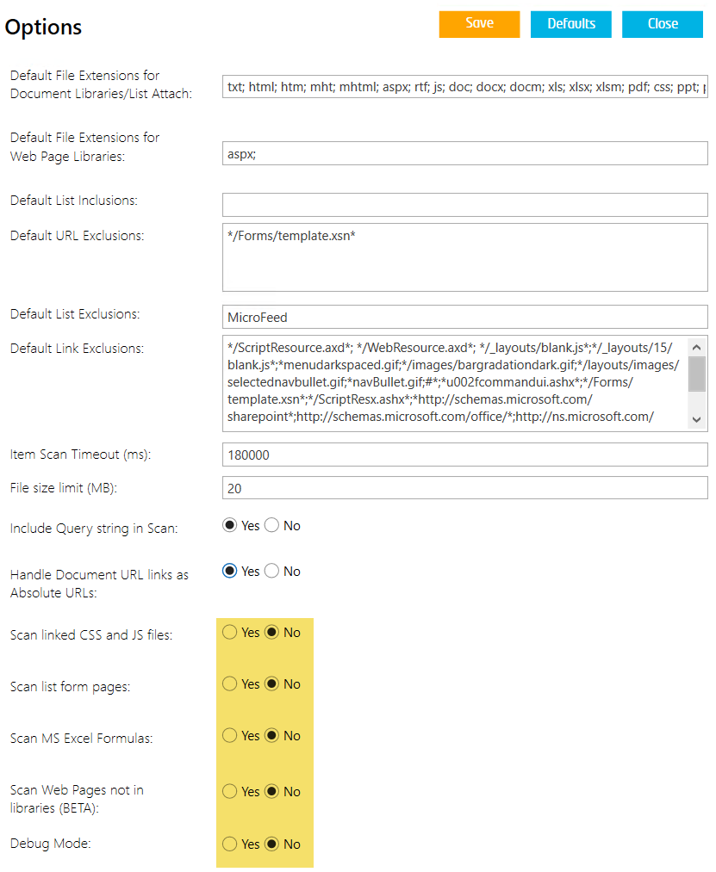

# Tips, Comments & Troubleshooting

* The utility can be paused to view the active logs and re-started as needed.
* If you encounter “The remote name could not be resolved”, you can follow these commands to get your machine to find the site again:
  + From the Start menu
  + Click Run and type “cmd” (or search for ‘Command Prompt’ from the apps page).
  + In the Command prompt window, type “ipconfig /flushdns” and press enter
  + Wait a minute and you should be able to browse and resolve the remote name (web site) correctly if it exists.
  + Close the Command prompt window.
* If you encounter a path that appears to show duplicate entries in the ‘Absolute URL Tested’ column, such as showing <http://contoso/projects/projects/tasks>, be sure to enter all custom SharePoint Managed Paths in the Settings page. See SharePoint Essentials Toolkit User Manual for more detailed information.
* If you encounter an error with “Details: The remote server returned an error: (404) Not Found.”, this can be caused by not setting the “SharePoint Managed Paths” in Settings page, or this may be related to an IIS setting that is complaining the content/url or query string is too large to be processed. You may need to increase the ‘MaxAllowedContentLength’ in IIS (Internet Information Services).

**References:**

<http://www.iis.net/learn/manage/configuring-security/use-request-filtering>

<http://www.iis.net/learn/troubleshoot/using-failed-request-tracing/troubleshooting-failed-requests-using-tracing-in-iis>

<http://blogs.msdn.com/b/sudeepg/archive/2009/11/10/content-deployment-the-remote-server-returned-an-error-404-not-found.aspx>

* Users with READ rights get an error when trying to retrieve sub site data:

“There was a problem enumerating sub sites. Details: Access denied. You do not have permission to perform this action or access this resource.”

Users require “Browse Directories - Enumerate files and folders in a Web site using SharePoint Designer and Web DAV interfaces.” rights. You can add this permission from Permission Levels in Site Settings -> Site Permissions.

* False negatives: If you have links that are reported as broken (Http Status Code 404) but when you open the site in Internet Explorer or other web browser and the web page loads correctly, there may be a few causes.
  + Be sure to set up correct authentication. In some cases you will need to change from Office 365 or Default SharePoint Authentication to use ‘Web Browser Authentication’. Look for errors in the log files that relate to unauthorized, which means you may have a federated environment or single sign on, which require Web Browser Authentication to connect.
  + Make sure all Managed Paths in Home->Settings are configured. See Managed Paths section in this document for more info on this.
  + Check the network traffic using tools such as Fiddler, we have found some pages may be incorrectly being resolved and redirected and reporting a 404 first and then redirects to a valid page. This may be an issue with DNS or the Http redirect code being used. We are working on providing a more descriptive status code for these situations to help identify these issues of page URL resolution/redirects. See below for example of this using Fiddler:

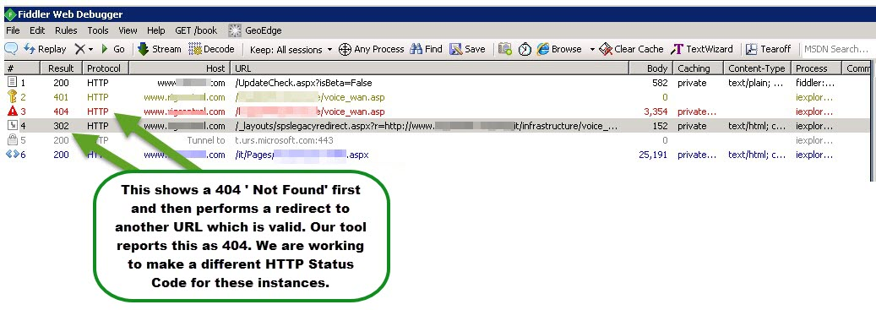

* If you have links in MS Office documents that only have absolute URLs, enable the option ‘Handle Document URL links as Absolute URL’ by setting it to ‘Yes’. This can help improve validation time of links within documents as it does not need to pass through certain logic.

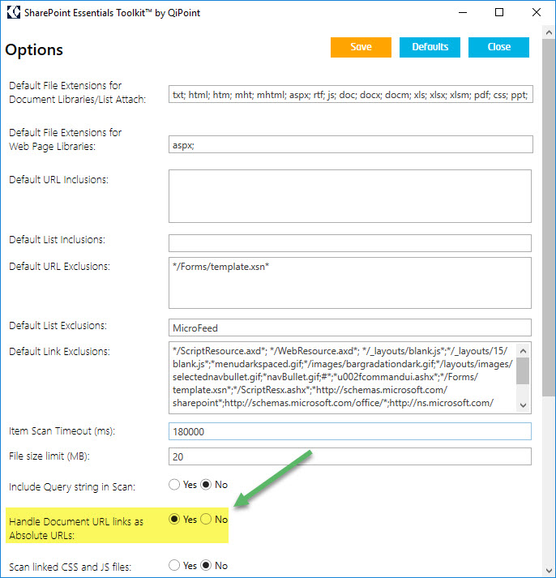

* For long running scans with more than 50,000 items, it is recommended to turn off the detailed logging feature to improve performance. This can be found at the bottom of the Scan Option section for Broken Link Manager page. Please also review the Minimum Hardware Requirements in this document.
* If you encounter “Could not load file or assembly 'Microsoft.IdentityModel, Version=3.5.0.0, Culture=neutral, PublicKeyToken=31bf3856ad364e35' or one of its dependencies. The system cannot find the file specified” a .NET framework component could be missing. Please download and install the Windows Identity Foundation component at <http://www.microsoft.com/en-us/download/details.aspx?id=17331>

If using Windows Server 2012, you can install the Windows Identity Framework using PowerShell (Add-WindowsFeature windows-identity-foundation), or Server Manager UI.

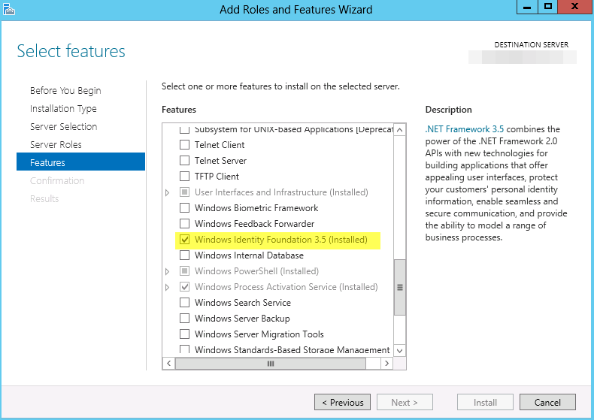

* If you receive errors such as “Forbidden” or “The communication object, System.ServiceModel.Channels.ServiceChannel, cannot be used for communication because it is in the Faulted state”. To resolve this issue, use Web Browser Authentication from the Credentials drop down.

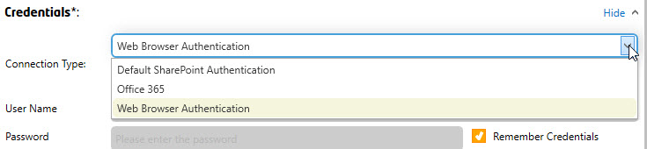

* If you receive errors of missing features when running a scan, or ‘<columnname> not found’, this may be due to faulty features or artifacts installed on the farm/site. The tool tries to retrieve information from a list/library and items to parse the contents within them. When a feature is missing or corrupted, the tool may report an error. This response is from the SharePoint API. To resolve this, find the missing/corrupt features and reinstall them or remove them from the site/farm.
* Links that require authentication – 401 Unauthorized – currently the utility uses the same authentication as the credentials added to scan the SharePoint site. So, if the link that is scanned requires a different authentication/user name and password, the utility displays a 401 unauthorized status message. You may add exclusions to jobs to exclude sites from appearing as ‘Unauthorized’, however, at this time the tool only supports one authentication set for all URLs.
* If scanning a site that is not from SharePoint or is not in the same web application, but it uses the same authentication provider and credentials as current user specified in tool, the site may show as a Redirect HTTP Status Code. This is because a redirect occurs to authenticate the user by passing security tokens across http. Treat these ‘Redirects’ as valid links, otherwise, the HTTP Status Code would be different, such as 404 Unauthorized or 404 File not found.
* If you encounter something like "Error parsing webpart 'Get started with your site' for page 'http://contoso/…/SitePages/Home.aspx'. Details: Exception of type 'Microsoft.SharePoint.SoapServer.SoapServerException' was thrown", be sure to have set the SharePoint Managed Path(s) in the Settings page.

## Improving time to complete Large Scan Jobs

The scan job takes forever to complete! How can I make it finish faster?

See these articles for more information:

#### [Broken Link Manager: The job takes a long time to complete, how can I make it finish faster?](https://cognillo.atlassian.net/plugins/servlet/servicedesk/customer/confluence/shim/spaces/CS/pages/29687824)

#### [Broken Link Manager: Performance and Memory Utilization, is 8GB enough RAM?](https://cognillo.atlassian.net/plugins/servlet/servicedesk/customer/confluence/shim/spaces/CS/pages/40697857)

#### [Broken Link Manager: Performance and Time to Complete 10GB Job?](https://cognillo.atlassian.net/plugins/servlet/servicedesk/customer/confluence/shim/spaces/CS/pages/59113473)

#### [Broken Link Manager: Performance and Time to Complete a Large Migration (1000-100K Site Collections, 100K+ subsites)?](https://cognillo.atlassian.net/plugins/servlet/servicedesk/customer/confluence/shim/spaces/CS/pages/59179017)

#### [Broken Link Manager: Filtering Links Before Job & How to Skip Repetitive Links? Such as in Mega Menus/Custom Navigation/Footers?](https://cognillo.atlassian.net/wiki/spaces/CS/pages/121110529)

You can improve scan job times by following the tips below:

1. We recommend breaking large site collections, or sites with large lists into multiple jobs.

Check/Select all sites (you want to build a report on) from the Home Page Dashboard, right click, and then click “Create Reports -> Broken Links” – this will allow you create multiple jobs (multi-threaded) at once.

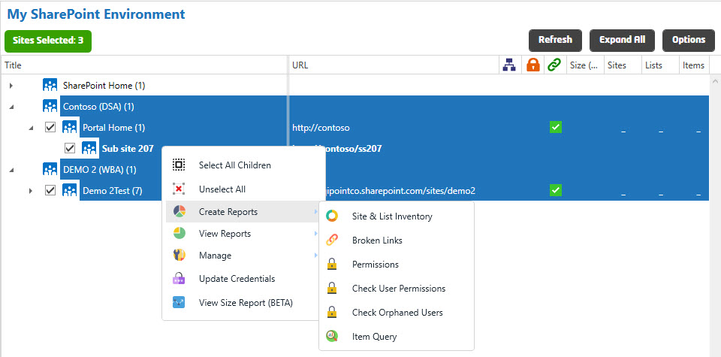

1. If you have a single site with many lists or one or more large lists (greater than 10K items), do not run this site in a single job. Instead, execute or schedule this job and use “Inclusion Rules -> List Inclusions” to separate each large list into a single job or multiple lists (if you have many) into a few jobs. For example, separate a site with 50 lists–10 lists per job. Again, you can create a Job Template (click “Save Job”) to make this easier.

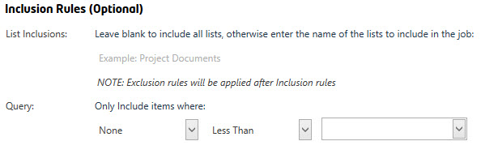

Then, you can then schedule these jobs to run in parallel (at the same Start Time).

***NOTE:*** *This potentially requires you to have more CPU or RAM or to run on a different machine to get the best results.*

1. Exclude content you do not need in the report. Set the “Exclusion Rules -> List Exclusions” to skip lists that are not needed in the report. Add any SharePoint URLs (such as folders or sections of a site) and Link URLs (links found within pages and files – such as navigation menu items) that you do not need in the report, or that you know are valid.

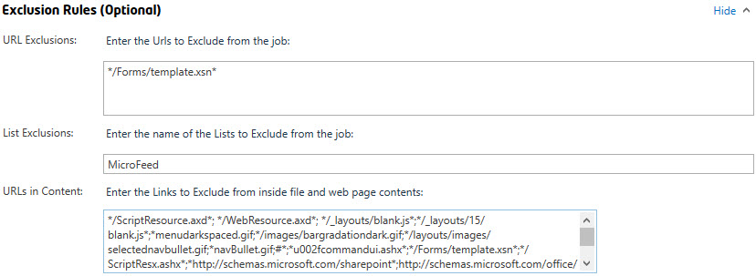

1. Disable “Show Detailed Logging”. Detailed Logging should be used when you are first setting up jobs to ensure they are working correctly and capturing the URLs and links you expect. This option is also useful when troubleshooting issues. Once jobs are tested and configured to run as needed, uncheck “Show Detailed Logging” to minimize the report time spent on writing each link found and other details.
2. If you are using “Scan List Attachment File Contents” or “Scan Document File Contents”, specify a lower “File Size Limit (MB)” in the Options page: Links (top navigation tab) -> Options (side navigation tab) -> File Size Limit (MB)”). Set the limit to 10MB, for example, to skip large files when scanning file contents. The default is set to 20MB.

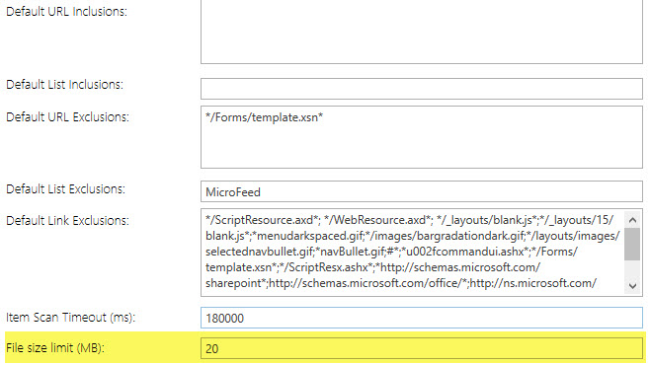

1. Turn off: Scanning Document URL links as Absolute URLs, Linked CSS and JS files, Scan list form pages, Debug Mode:

Go to the "Scan Links (tab) -> Options" page, make sure the following are turned off these 'optional' settings: (they are OFF by default)

“Include Query string in Scan”

"Handle Document URL links as Absolute URLs"  
"Scan linked CSS and JS files"  
"Scan list form pages"  
“Scan MS Excel Formulas”

“Scan Web Pages not in libraries (BETA)”

"Debug Mode"

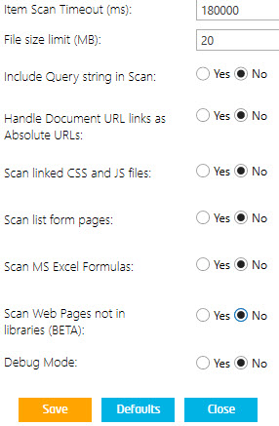

1. Ensure the folders below are not being scanned (excluded) by anti-virus ‘on-access’ scanning, as well as excluded from any offline syncing, such as OneDrive, Google Drive or Drop Box. Also, exclude subfolders of directories below:

* C:\Users\UserName\AppData\Local\Temp\Cognillo
* C:\ProgramData\Cognillo
* <My Documents>\Cognillo

# Technical Support

If you need technical assistance, please use the link below to contact us!

<https://www.cognillo.com/support>

We are here to help!

# Product Features

|  |  |
| --- | --- |
| Feature | Enterprise |
| Scan SharePoint 2010 | P1147C4T3#yIS1 |
| Scan SharePoint 2013 | P1150C6T3#yIS1 |
| Scan SharePoint 2016 | P1153C8T3#yIS1 |
| Scan SharePoint 2019 | P1156C10T3#yIS1 |
| Scan Office 365 | P1159C12T3#yIS1 |
| Scan SharePoint Sites | P1162C14T3#yIS1 |
| Scan Web Page meta data | P1165C16T3#yIS1 |
| Scan Specific Site for an individual Report | P1168C18T3#yIS1 |
| Searching within Report | P1171C20T3#yIS1 |
| Querying results in the Report | P1174C22T3#yIS1 |
| Report in customizable grid | P1177C24T3#yIS1 |
| Scan Page Libraries and ASPX Page Content | P1180C26T3#yIS1 |
| Scan Content Editor Web Parts | P1183C28T3#yIS1 |
| Scan Navigational links in pages | P1186C30T3#yIS1 |
| Scan Custom Navigation in pages | P1189C32T3#yIS1 |
| Scan Custom Web Parts in pages | P1192C34T3#yIS1 |
| Scan List Item meta data | P1195C36T3#yIS1 |
| Scan Document meta data | P1198C38T3#yIS1 |
| Export to CSV / MS Excel | P1201C40T3#yIS1 |
| Grouping of Scan Results in grid | P1204C42T3#yIS1 |
| Detailed Report on broken links | P1207C44T3#yIS1 |
| Scan Entire Site Collection in single job | P1210C46T3#yIS1 |
| Exclusion Rules (SharePoint URLs) | P1213C48T3#yIS1 |
| Exclusion Rules (SharePoint Lists) | P1216C50T3#yIS1 |
| Exclusion Rules (URLs within items/pages/files) | P1219C52T3#yIS1 |
| Inclusion Rules (SharePoint URLs) | P1222C54T3#yIS1 |
| Inclusion Rules (SharePoint Lists) | P1225C56T3#yIS1 |
| Scan Document Library File contents | P1228C58T3#yIS1 |
| Scan List Item File Attachment contents | P1231C60T3#yIS1 |
| Scan within All ASCII, UTF-8, MIME, TXT File Types | P1234C62T3#yIS1 |
| Scan within MS Word Document Contents | P1237C64T3#yIS1 |
| Scan within MS Excel Document Contents | P1240C66T3#yIS1 |
| Scan within MS Project Document Contents | P1243C68T3#yIS1 |
| Scan within MS OneNote Document Contents | P1246C70T3#yIS1 |
| Scan within PDF Document Contents | P1249C72T3#yIS1 |
| Scan within InfoPath Form Contents | P1252C74T3#yIS1 |
| Email results automatically to users | P1255C76T3#yIS1 |
| Automatic Find \ Replace URLs | P1258C78T3#yIS1 |
| Schedule Scan Jobs & Report Generation | P1261C80T3#yIS1 |
| Export Reports to SharePoint List | P1264C82T3#yIS1 |